Nari Associate for Revival and Initiative (NARI)
Project
Annual Progress Report
July 2006 to June 2007

Submitted to:
HEKS-Switzerland
Zurich

Submitted by:
Bangladesh Development Service Center (BDSC)
House # 299/A, Road # 2
Baitul aman Housing society, Adabor, Shyamoly
Dhaka -1207, Bangladesh
Phone: 8121826, 8127226
E-mail: bdsc@bol-online.com

Contents: | Page
A. General overview of NARI project: | 3
Introduction: | 3
B. Addressees of the report | 3
C. Structure for the report | 3
1. General retrospect of the reporting period | 3
1.1 Political main events in Bangladesh | 3
1.2 Economical main events in Bangladesh | 4
1.3 Sociological (caste/class/gender/religion) main events in Bangladesh | 4
1.4 Human rights situation in the project areas | 4
2. Activities of the partner organzation during reporting period: | 5
2.1 Main focus of the work in relation to the project proposal: | 5
Goal of the Project | 5
Specific Objectives | 5
Activities accomplishment: | 5
i. Weekly meeting  ii. Union Nari executive Coommittee(UNEC)  UNEC, the “WHEEL” of Women Empowerment  iii. Upazilla Executive committee(UPEC) Meeting  iv.Union conference  v. Workshop and Meeting  vi. Project Coordination Review Committee(PCRC)  vii. Information of training and group meeting  viii.Information of union wise savings  ix. IGA Input Support to Group Members | 5  6  6  7  7  8  8  8  9  9
Successful example of NARI Initiatives in IGA | 9
Achievement of Sahima | 9
They are owner of their own production | 10
Sad story end of Asma Begum | 11
x. Day Observation | 11
2.2 Goal reached | 11
2.3 Goal not reached | 12
2.4. Main problems | 13
3. Outlook for the coming reporting period | 13
3.1 Main focus | 13
3.2 Action envisaged to overcome problems | 14
3.3 New/additional areas of activities (if any | 14
Project staff team | 15
Conclution: | 16
Annex-1  Target and achievement for the period July 2006- June 2007 | 17

A. General over view of the NARI project:

Introduction:

Nari Associate for Revival and Initiative (NARI) is a very challanging project as well as ambicious project. The project primarily initiated by BDSC in January 2006 and continued upto June 2006 as pilot phase. Thereafter, it comissioned as long-term development program in order to bring positive changes in the lives of the Community Sex Workers (CSWs); one of the vulnerable segments of the population in Ulipur Upazila under Kurigram District since July 2006.

Vulnerable socio-economic condition of the women pushed them to take the profession. Insecurity of the livelihood bound the women to sell their sex. But society does not accept the profession. So the women are on the one hand in economic pressure and on the other hand social pressure. So it is difficult for the women to come out from the trap easily and shortly.

The project has taken innovative strategies, appropriate technique, tools and realistic actitivites. Due to the project’s contribution a sign of good change is being observed. As mentioned earlier, it is difficult but not impossible. IGA activities are contributing to economic security and groups/ forums have been serving as platform, from where they have started to raise their vioce againgt social injustices and which are contibuting to achive the project goal.

Already 41 groups have been formed among the target beneficiaries those are right now receiving skill development training in multifarious aspects and regular group session are conducted weekly basis on different issues by the field staff. So that after the completion of this project, these groups can be introduced as individual community based organizations or they will make a forum-base sustainable self-help organization. A total of 600 CSWs have been included into the project while the project area covers 43 villages of 8 Unions of Ulipur Upazila under Kurigram district. The beneficiaries have started various IGAs like backery, cow rearing, paddy cultivation, nursery, etc. Their income is increasing but it will take more time to be fully independent. Leadership capacity and skill of some women have increased, they have started to take some independent decisions in order to protect social problems like violence against women, early marriage, dowry, etc..

During this period (July 2006 to June 2007) the project completed all most of it’s planned activies. As well as there established a strong relationship with project participans and local administration. The main focus of the report is to articulate progress of planned activities, goal achieved, not achieved, challenges, overcome procedures and also the next steps to be taken for achieving project goals.

B. Addressees of the report:

This report is prepared for HEKS, Zurich, their board and their back donors. BDSC hopes that the report would be enough to describe reader about the project activities, progress, prospect, challenges and future direction of the project.
C. Structure for the report:

1. General retrospect of the reporting period

1.1. Political main events in Bangladesh

2006 was the last year of the last ruling party Bangladesh Nationalist Party. Since, the last year is usually the critical time of each of the ruling party and the high time for the oposition party to try to oust the ruling party from the power in the political context of Bangladesh, so 2006 was not the exception of that. Nevertheless, such a political restlessness like 2006 has ever been happended in the political history of Bangladesh that was continued up to January 2007. The main issue of the political crisis was parlamentary election that was supposed to be held in January, 2007 under the Caretaker Govt. as per the constitution that was introduced in 1991 after falling the autocratic government which was running by applying martial law. However, in October, 2006, at least 50 people were killed by severe political agitation centering the issue of occupying the power of ruling the country by influencing the election commission that subsequently made the socio-economic situation stagnant and law and order was deteriorated dreadfully. At last, in January 11, 2007, a new caretaker govt. was formed with the back support of Millitary that declared emergency in the country for indefinite period. In the mean time, a good number of political leaders including two former Prime Ministers have been imprisoned. The present govt. is expecting to hold election at the end of 2008 and voters listing is under the procedure. Alongside, listing the voters, ID card for the voters is also on the process. The political situation has become calm, as political acitivites are totally banned.

1.2. Economical main events in Bangladesh

A devastating flood engulfed the country and more than half of the landmass gone under water, as a result the economy critically affected. The working area of the project i.e. Ulipur Upazila was severely affected. The project beneficiaries were also affected, as a result the vulnerability of the women increased. Overall the flood had created a drawback on the economy of the country.

Although, GDP of Bangladesh has raised over the last 5 years, but due to political unrest and flood, now it has dropped sharply. Due to political agitation, foreign investment has also dropped that has affected the total economy of the country. In the middle of the year garments workers started chaos demanding to increase their salary and other benefits but later on the matter was setteled. Besides these, since, many of the businessmen are also in the prison right now due to corruption or other charges, so their business organizations also has become stagnant. Prices of the essential commodities have raised sharply, as a result poor as well as lower middle class people are critically affected. Moreover, the present caretaker govt. has ruled out some instructions to the business organizations for which right now the economy of Bangladesh is passing a very critical time that is affecting from the beggars’s daily income to the nations’ GDP. On the other hand, in the name of international market price, the price of the daily necessaries is being sky high which is beyond the reach of most of the people. Consequently, in one hand, the gap between poor and rich is expanding, on the other hand, extreme poor do not have any other choices but being on starvation.

1.3. Sociological (caste/class/gender/religion) main events in Bangladesh

Due to the political restlessness and economic vulnerability, unemployment rate has increased tremendously that again creates crimes and anti-social actitivities. On the other hand, eviction without arranging rehabiliation for the poor people who used to live in slums in the urban areas or in the Khas land, their sufferings and miseries knows no bounds. Big cities are getting full of the homeless people having uncertainty of their jobs and food and shelter. The rest of the people who do not have any options to leave their villages, they are to stay there but on starvation especially the poor people of Monga (near famine) prone areas just like Ulipur upazila of Kurigram District. Nevertheless, two big festival of muslims, one big festival of hindus, one big festiva of christians and one big festival of buddist were observed without any problem. Chittagonj Hill District’s problem has become calm. Violence against women and social stima is still prevailing in the society but the sign shows a very little positive change.

1.4. Human rights situation in the project areas:

As per the constitution of Bangladesh, all of it’s citizens are supposed to have a certainty to lead normal social life fulfilling 5 basic human rights. But the project participants of NARI are being bereft of having almost of all of these basic human rights. Due to the vicious circle of poverty, they have been sunk into the dark world where dignity is being turmoil in every step and they are being the victim of exploitation and extortion that is a clear violation of CEDAW. It is to be mentioned here that Bangladesh is one of the signatories of CEDAW too, but unfortunately, its’ application is about zero in the project area. When, the CSWs of Ulipur were passing such an utmost situation where they did not have any other choices but for sex trade, at that time, NARI project entered into their lives as an opportune and authentic change agent. Because, NARI project is implementing its’ program activities by emphasizing on the human rights based issues and is advocating at all levels to make the community people understand and internalize the rights of the CSWs as other poor women do have as human beings. In this approach, the project has already proved its’ efficiency. Because, albeit, in the very beginning of the project implementation, the community people made a resistance against the program, but no sooner had they conceptualized the theme of the project, they began motivated to assist the project.

2. Activities of the BDSC organization during reporting period:

2.1. Main focus of the work in relation to the project proposal:

Goal of the Project

To improve the socio-economic condition of the Community Sex Workers (CSW) for building their institution.

The Specific Objectives of the project are:

- Revive the Community Sex Workers (CSW) from selling sex for family survival.
- Enhance women groups of CSW for building their own institution by development leadership skill
- Impart viable skill training for alternative income in the community level.
- Ensure financial support for individual and collective intervention for creating employment opportunities.
- Enhance community participation and cooperation to change life style of community sex workers.
- Provide social and moral education to women and children about rights and access to development services.

Activities accomplishment:

Every project is intended with some planned activities. The plan would be completed step by step to achieve the goals of the project. The NARI project already passed one year from it’s inception. During this period the following activities were completed:

i. Weekly meeting:

Every Community Development Organizer (CDO) conducted regular weekly meeting at the group. In those meetings they discussed different issues in order to raise awareness of the participants. During this year the issues were discussed i.e. Muslim family law, divorce, early marrage, pollygamy, women rights, gram adalat (village arbitation), health-hygiene behebior change, family planing, etc and also discussed the importance of change their present life style. Each NARI group consists of 12 to 22 members. The members are depositing their savings money in the meeting. They discussed problems and prospects of their social and personal life. All kind of discussion topics and decisions were recorded in the specific register book. Total 870 meetings were held out of 987 meetings. Presently the CDOs are conducting the group meeting, but in future the group leader of NARI will be capable to conduct their group meeting by themselves.

ii. Union Nari executive Coommittee (UNEC):

There were 7 UNECs formed in the project area. The Chair person and the General Secretary of the NARI groups are the member of the respective UNEC. The UNEC is a coordination forum at the Union level. This is a very important platform to cooperate with the union parishad as well as local government bodies. On the other hand the NARI groups shared their successes, problems and its solutions procedure in the meeting as a greater forum. The UNEC Meeting were held monthly basis as per plan of action. Total 84 meetings were held during this period and average 10 women were present in those meetings. The UNECs have taken step to protection of early marriage, dowry, polygamy and discriminations against women.. The meeting information is given bellow:

Participants of UNEC meeting
Union | Place of meeting | Participants
Union | Place of meeting | Male | Female | Total
Buraburi | Buraburi Union Parishad Office | 0 | 108 | 108
Takabpur | Takabpur Union Parishad Office | 0 | 119 | 119
Dhamsreni + Pandul | Dhamsreni + Pandul Union Parishad Office | 0 | 51 | 51
Hatia | Hatia Union Parishad Office | 0 | 148 | 148
Gunaigach | Gunaigach Union Parishad Office | 0 | 116 | 116
Bozra | Bozra Union Parishad Office | 0 | 151 | 151
Daldalia | Daldalia Union Parishad Office | 0 | 118 | 118
Total |  |  | 811 | 811

UNEC, the “WHEEL” of Women Empowerment:

Shaympur, a village located in Hatia Union, one of the project areas of NARI project under Ulipur Upazila where Ayesha the leader of UNEC lives. She has been involved with the activities of NARI project since its’ inception. Since, she is also one of the victims of social extortion and exploitation due to having the profession sex trade, so she is always in an endeavour to save other women from the similar vulnerability she stands in. One day, it came to her knowledge that, Pachani, a little girl of 13 years old were about to compel to get marry arranged by her parents and moreover, that was going to be happened with an anti-social activist in lieu of dowry. As, Pachani’s were in dark in regard to have accurate information in connection with the country’s existing family laws, child rights, women rights and the extent of punishment against the violence of women, so they gladly accepted the proposal of Pachani’s marriage and they did not wast time. Rather, they were making hurry to arrange the marriage albeit, the kid’s aunt was persisting her parents not to arrange marriage with that man especially when she knew the man personally. Nevertheless, due to poverty, Pachani’s parent wanted to get rid out of the “BURDEN” Pachani and did not give ear to her aunt’s information. But no sooner had Ayesha got this news, she rushed to Pachani’s house and tried to make her parents understand about the negative of early marriage. Even though, Pachani’s parents did to want to understand the situation rather they were seemed to be very much stubborn about arranging her marriage. Thereafter, Ayesha contacted with her other members of UNEC and arranged a meeting where along the parents of Pachani and other community people were present. At that meeting, all the members of UNEC provided the information on existing laws as well as punishment against early marriage, marriage registration, women and child oppression and above all, the dreadful physical impact on a child for early marriage. Other community people who were present at that meeting also internalized the impact of the above mentioned issues and were agreed with Ayesha and other UNEC members and put pressure upon the parents of Pachani to stop the marriage. At last, on the presence of all, Pachani’s parents confessed and promised that not only in the case of Pachani, rather, they are no more interested to arrange marriage for any of their daughters before 18 years of age.

iii. Upazilla Executive Committee(UPEC) Meeting:

The Upazilla Executive committee (UPEC) is the top most coordination forum of NARI project. The representatives of all UNECs (Chair person and general secretary) are the members of the forum. There is a powerful executive committee with seven members who were elected by general member of the forum. The UPEC has a bank account and the UPEC committee has handled the revolving fund by the guidance of BDSC. The committee is issuing cheque to the selected NARI members for their indivdual and partnership IGA. The UPEC meetings were held monthly basis by the participation of UNEC representatives. The meeting information is given below:

Union | Place of meeting | Participants
Union | Place of meeting | Male | Female | Total
All union | BDSC Training Centre | 10 | 195 | 205
Participants of UPEC meeting
iv.Union conference:

The conferences were arranged at the union level. The project participants were sharing their success failure with each other and learn from each other. Through this conference they find out the innovative idea and way of problem solving process. There are 24 conferences held during this year and participated total of 916 participants. The information is given below:

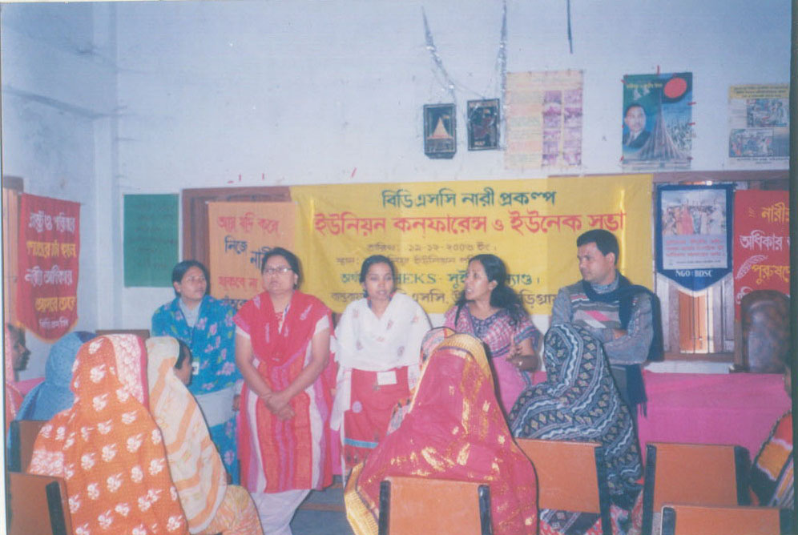
Union | Place of meeting | Participants
Union | Place of meeting | Male | Female | Total
Buraburi | Buraburi Union Parishad | 43 | 71 | 114
Tabakbpur | Takabpur Union Parishad | 78 | 78 | 156
Dhamsreni | Dhamsreni Union Parishad | 49 | 61 | 110
Hatia | Hatia Union Parishad | 35 | 44 | 79
Gunaigach | Gunaigach Union Parishad | 52 | 52 | 104
Bozra | Bozra Union Parishad | 56 | 66 | 122
Daldalia | Daldalia Union Parishad | 48 | 83 | 131
Pandul | Pandul Union Parishad | 42 | 58 | 100
Total |  | 403 | 513 | 916
Union Conference

v. Workshop and Meeting:

Different kind of workshop and meeting were arranged by the participation of government officials, local elites and religious leaders. Through those workshops and meeting all part of the society know about the NARI project and its activities. The project participants and the civil society all side get together to exchange their view. They also find out the way of possible cooperation to make the project succssful. This is a very important event to making an effective way of cooperation with other influential stakeholders. The information of workshop and meeting is given below:

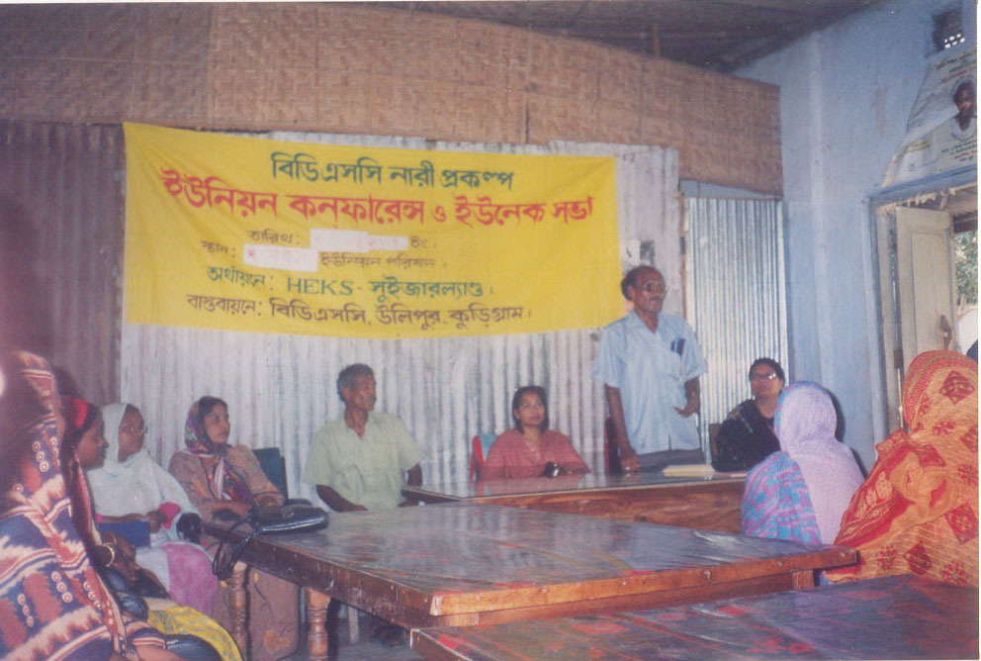
Particulars | Participants
Particulars | Male | Female | Total
Workshop | 77 | 152 | 229
UPEC & Govt. Official and local leader | 20 | 48 | 68
PCRC meeting | 63 | 133 | 196
Total | 160 | 333 | 493
Meeting with local leader

vi. Project Coordination Review Committee (PCRC):

The PCRC were formed with 9 members by the participation of Government high level (Upazila basis) officials, NGO representatives, religious leader (Emam) of the Upazila central mosque, and chair person & general secretary of UPEC and coordinator of NARI project. They sate together every month and review the progress of the project. This is a very important coordination forum to disseminate the view of NARI project to others and a effective way to establishing net work with GO, NGO.

vii. Information of training and group meeting:

Different kinds of training were held during the Period. Leadership¸ Human right and legal issue were the life skill training. In those training they know i.e. the characteristics of a good leader, leadership pattern, responsibilities of the leader, concept of human right, violation of human right and the way of the established of human rights and also they were aware about different legal issues. On the other hand some training was arranged for based on Income Generating Activities (IGA). Through those training the women of NARI project will be life skill as well as they will be able to empower in the family and in the society. The effect of the training is found a positive change among the NARI leaders, as well as some members were taken initiative to start different IGA activities after receiving training. The training information is shown in the table:

Particulars | Days | No. of participant
Leadership | 3 | 102
Human rights & legal issue | 3 | 100
Cow rearing | 5 | 135
Small trade | 3/5 | 151
Accounts Management | 5/7 | 55
Group meeting | - | 870

Training on leadership for group leaders of NARI project
viii.Information of union wise savings:

The group members of NARI project were started savings for their financial sustainability. Every NARI member deposited five taka as savings in their weekly group meeting regular basis. They have group basis bank accounts and they deposited their group savings in that account. In future they will use that savings money as revolving loan fund among themselves. This is the way of financial sustainability of the groups. The savings information is shown in the table:
Name of Union | No. of samity | No. of member | Saving amount
Hatia | 7 | 100 | 28,070
Daldalia | 5 | 75 | 21,117
Buraburi | 6 | 100 | 28,262
Tobakpur | 6 | 87 | 21,700
Bozra | 7 | 87 | 25,241
Pandul | 2 | 25 | 6,711
Gunaigach | 5 | 76 | 19,867
Dhamsreni | 3 | 50 | 11,381
Total | 41 | 600 | 162,349

Training on accounts & group management
For group members of NARI project

ix. IGA Input Support to Group Members:

Income Generating Activities (IGA) imputes support were an important element for reducing the vulnerability of the CSWs and also has created the alternative income source of them. The amounts were distributed among 295 members in favour of different trade and professions of NARI project members. The result of this inpute is found positive in some trade and others achievement would be found in near future. The seed money for the CSW’s to making a financial foundation for them. The Union wise disbursed amount is given below:

Union | No. of Group member | IGA input support to persons | Taka | Cattle |  | Small trade |  | Paddy cultivation |  | Nursery
 |  |  |  | Group wise | Personal | Group wise | Personal | Group wise | Personal | Group wise | Personal
Hatiya | 100 | 55 | 275000 | 10 | 08 | 02 | 14 | 16 | 0 | 5 | 0
Daldalia | 75 | 29 | 120000 | 00 | 15 | 00 | 14 | 00 | 0 | 0 | 0
Buraburi | 100 | 43 | 209000 | 10 | 08 | 08 | 08 | 09 | 0 | 0 | 0
Tobakpur | 87 | 46 | 218000 | 04 | 18 | 06 | 10 | 05 | 0 | 3 | 0
Bozra | 87 | 44 | 199000 | 00 | 18 | 00 | 20 | 06 | 0 | 0 | 0
Pandul | 25 | 18 | 85000 | 06 | 01 | 00 | 05 | 06 | 0 | 0 | 0
Gunaigach | 76 | 34 | 129000 | 00 | 13 | 00 | 16 | 05 | 0 | 0 | 0
Dhamsreni | 50 | 26 | 115000 | 00 | 09 | 02 | 15 | 00 | 0 | 0 | 0
Total | 600 | 295 | 1350000 | 30 | 90 | 18 | 102 | 47 | 0 | 8 | 0

Due to the IGA support economic situation of the women has started to improve. Average monthly income of the beneficiary has increased. Economic sustainability will not come within very short time, but it is an gradual improvement. The table below shows the details.

Sl. | Name of Trade | Average Monthly Income | Remarks
1 | Cattle
2 | Small trade
3 | Paddy cultivation
4 | Nursery

Successful example of NARI Initiatives in IGA:

Achievement of Sahima

Shahina is living in the village of Kalpani under BAZRA union of Ulipur Upazila. Before 24 years ago she was got marriage with Md. Abdur Rashid near by her village. During her conjugal life she has to gain three daughters and has to able settled marriage two daughters, one is now reading in class three. Before one year her husband had to disabled by paralysis. She feels darkness around her and she involved with various profession to earn for her family. But she feels exhausted to carry out her family to provide basic needs. At that time she had to involve with NARI project as a group member. She received training from BDSC on cow rearing and received credit Tk.5000.00 and she added another Tk. 5000.00 by selling her own tree with it. By this money she purchases a pregnant cow, which gives her a beautiful female calf after 8 month. At present her cow is giving three litters milk every day. She used to selling two litters and rest has used Visited by HEKS Bangladesh Coordinator of milky cow
to fill up nutrition need Rearing project under NARI project
of her family. Now she is able to maintain her family with dignity and she is very happy by her great achievement in her disaster life.

They are owner of their own production:

There are no NGOs who are interested to encourage the partnership initiatives at the community level in Bangladesh. But NARI has to success in their partnership initiative. Mono-Ara, Kadvanu, Golenoor and Sahiron is the member of a NARI group under Buraburi union near by village of islam bazer. They received training on Paddy cultivation from BDSC and received credit Tk. 25000.00 for ledge a piece of land. They also used their money for purchasing fertilizer, seeds etc. They were together invest their labor in their own agriculture field and produced 28 mons(1mon= 40 Kgs) Paddy. Partnership Paddy cultivation
Every partner gets 7 mons paddies for the first time. This was very charming for them. Because, they always produced for other, but this was the first time they are owner of their own production.

Sad story end of Asma Begum

Asma Begum lived in Dhamsreeni union, village of Darika under Ulipur Upazila. She was very poor and her husband was a agricultural labor. They were sold their homestead for their only daughter marriage ceremony. Then she lived with her husband near by her husband’s brother’s house. After some days they abondoned from there and taking selter near by their aunt house. In that time Asma joined with a NARI group and started savings. After some days she received training from BDSC on smoll bussiness and received credit TK. 4,000.00 from NARI project. She started her bisuness with her husband and they have come to a solvent position. In the meantime her husband become in illness. She feel darkness around her and she could not understand, what she could do now ? At last she come to a decision that, she will continue her Asma Begum
business and she do so. Now Asma is continuing her business and able to maintain her family and also provided threetment of her ill husband. Asma Begum is very hopeful to ending her sad story and she is dreaming for an own house near future.

x. Day Observation:

International women day was observed in this year. The NARI project participants, GO-NGO representatives, educationist and the representatives of civil society were participated in the occasion. This was a mass gathering for awareness rising among the people on women rights and protection of violence against women. BDSC has arranged the function by the cooperation of others NGOs and Upazila administration. This was a great opportunity to introduce the NARI women with the mass people of the Upazila. In this function the women were disclosed their views with the mass people and feel encourages.

2.2.Goals reached:

Goal is the bigger aspect of a project. It is not easy to reach the goal within a year or within any short term period. On the other hand goal reach means the project was achieved a lot, almost interventions are implemented successfully. The NARI is an on going project and the reporting period is since the inception of the project. This was a very short time to measuring the project goal. Although some positive indicators are mentioned below as goal reached partially:

- Economic security of some families has increased.

- Some of CSWs are aware of the negative impact of their profession.

- Few of the family members of the CSWs are now aware of the illegitimacy of the profession of the CSW.

- Groups are feel enthusiasm to improve their unity.

- Groups are going to follow a precise roles and regulations.

- Nari women are very positive to the NARI project’s activities and they are interested to learning for their future life. NARI women involved in agriculture work.

- Nari women are introducing with GO-NGO level and also the civil society through different workshop, meeting etc. This is a positive indicator of societal acceptance.

- BDSC were provided some skill development training for IGAs and in the consequence of that, the target beneficiaries are developed their business like; bakery, restaurant, few Women involvement in agriculture
- number of grocery shops and also few are selling home made food in the market. This are involving them in the alternative professions.

- The acceptability of the CSWs are increasing in the society day by day, they have started movement especially to purchase something from the market by their own. Previously, their mobility was restricted by the local political and influential people.

- Few, CSWs are providing financial support to their families from their alternative incomes rather than Sex Business by which they are motivating to involving with alternative profession.

- The close relationship of the CSWs are developing to the community. They are attending their group meeting, sharing their view in different level of the society, like as UNEC, UPEC forum and also joined the workshop, seminer in the Upazilla level.

2.3 Goals not reached:

As it mentioned before that, during a certain time recognized goal may achieved partially, then it can not say, it reached the goals. In regard to consider it, mention goals are not reached below:

1. Social barrier is not reduced in a significant position of the CSWs in regard to conservativeness of the society.

2. Leadership skills are not reach optimum level to leading a group independently. On the other hand the leaders are not fully motivated to take the responsibility of the group.

3. There is a lacking of financial management to operate their savings and credit activities. Due to this some ideal savings fund is not utilizing properly as revolving credit

4. A few persons of CSWs are involved with IGA; it need more persons involvement to increase their family income which may revive them from sex business.

5. The CSWs are not fully leaving their previous profession (sex business) and community peoples are not motivated to help them to revive normal life.

6. Awareness on women rights, legal issues and gender sensitiveness is in a poor situation of the CSWs.

7. Relife minded attitude make their expectation high, which is linger self-help development process in view of achieved project goals.

8. A fare and trustful environment is not significantly created in the group, UNEC & UPEC level, which is linger sustainability process to achieved project goals.

2.4. Main problems:

During the implementation of the project, the organization had to face some challenges/problems also alongside it’s progress among which, the following are remarkable:

      - Political unrest is very common in Bangladesh. 2006 was the last year of the last ruling party Bangladesh Nationalist Party (BNP). In this regard a political hazard was scare to implement the project smoothly.
- Some of the project areas were inundated during the last severe flood. But on behalf of the project, neither any disaster preparedness activity nor post disaster activity was initiated which has given a little bit disappointed impression about the project in the community.
- Less presence of the target beneficiaries in the group and UNEC (Union NARI Executive Committee) as they are to get engaged in seasonal works like: infrastructure development work (road improvement) by other NGOs or international development projects (RDRS, CLP) and agricultural labour work.
- School authority was getting agreed to admit the children of the CSWs into school on account of their illegal profession.
- The Field Staff could not render training effectively as they did not have clear concept about the specific issues. They were not given any basic training.

3. Outlook for the coming reporting period:

3.1. Main focus
After having experience from the previous implementing period, BDSC has planned to focus on such kind of issues that are essential to be addressed for the sustainable development of the beneficiaries of NARI project. The following are some of them that have been planned to be addressed in the coming period:
- Gender equity and diversity at all levels of the project management i.e., from the program activity planning to implementation.
- Social mobilization on rights based issues and women empowerment.
- Livelihood improvement of the beneficiaries through providing skill development training on different trades so that they can lead a normal and sane social life with human dignity.
- Ensure normal social life of the children of the beneficiaries of the NARI project through Participants of agricultural training mainstreaming their children by initiating appropriate activities like: make arrangement of formal education for their children, life skill training, awareness raising on human rights etc.
- Advocacy at different levels of policy makers.
- Develop self-help groups through organizing institutions among the beneficiaries.
- Increase awareness among them on their rights they deserve and legal aids on different legal issues.
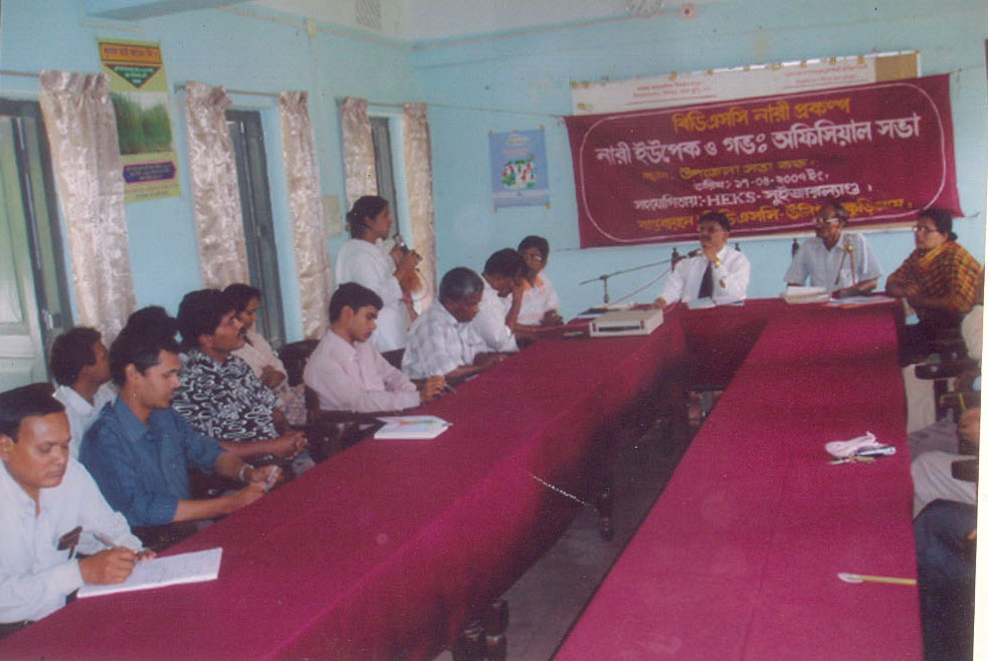
3.2. Action envisaged to overcome problems listed under 2.4 and to reach goals under 2.3:

- Since, the Govt. high Officials of different department are seemed to be very active and earnest to cooperate the NARI project, so the more the project will be benefited by them, the more their involvement and active participation increases. Consequently, it will reduce the unwanted interference and resistance of the local influentials. At the same time, CSWs also can have public services on account of their acquaintance at different level stakeholders.
- There are many abandoned water bodies and khas land owned by the govt., that can be taken as lease with the UPEC and Government official meeting
memorandum of understanding with the govt’s concerned agency. Thereafter, that can be allocated to the CSWs for their shelter and alternative livelihood options.
- It need more attention to involved local influential persons as a change maker or motivates them to participate with the project as a sacred work.
- Due to illiteracy of the CSWs, IGA selection for them need more practical oriented as per their skill, which help to creat long term employment generation.
- Considering the staff development, some capacity building training can be arranged that has already been taken into the plan of the coming action plan of the project. Besides this, considering the sufferings of the target beneficiaries during disaster, some program activities have also been included in the next years action plan.

3.3. New/additional areas of activities (if any)

- Gender and development, M&E, Report preparation, Resource mobilization and management, Action plan and Budget preparation.
- Provide basic training to the community volunteers on agriculture, health care delivery system and basic health care, child and women rights.
- Conduct session on literacy and numeracy, rights-based issues, empowerment to CSW groups and adolescent girls within the same community.
- Develop and prepare various IEC materials like Bill board, Poster, leaf let, brochure, Calendar, Directory of service providers, etc. on women rights, violence against women, child rights, AIDS/HIV/STD, women empowerment.
- Organize annual retreat for learning sharing and new idea generation for the revival of the vulnerable women of the NARI project.
- Natural disaster i.e. flood and drought are very common in this areas. Disaster management training is very essential for the NARI project participants.
- Organize meetings with the concerned agencies/department of the GOB like: Department of Women and Child Affairs, Law enforcings agencies, Lawyers, Department of Education, Department of Health and Family Planning and other NGOs working with the similar target beneficiaries.

In the mean time, the project has been able to draw attention of different level stakeholders that is very much essential to accelerate the project and sustain the development of the target beneficiaries. Due to the direct involvement of the govt’s Department of Women and Child Affairs and the trend of getting involvement of the community people in the project’s different events, the CSWs feel inspiring to raise their issues in the right forum especially in terms of legal support, internalizing the negative impact of their previous profession and showing interest to avail the opportunity of alternative livelihood, they are getting courageous after being included in NARI project. One of the CSWs is now taking preparation to get nomination of Union Parishad member in the coming election which indicates their empowerment is not so far that they are dreaming by the project.

Project staff team:

Sl. No. | Name of staff | Education | Designation | Joining date
1. | Syada Farida Yesmin | BA | Project Coordinator | July 2006
2. | Sunil Kumar | B. com | Accountant | January 2006
3. | Hamidur Rahaman | BA | Traineer cum supervisor | ,,
4. | Rebeka Sultana | BA | ,, | ,,
5. | Anima Rani pal | HSC | Community Organizar | ,,
6. | Anguman-Ara begum | HSC | ,, | ,,
7. | Gulshan-Ara Khanam | HSC | ,, | ,,
8. | Protima Rani | HSC | ,, | ,,
9. | Saya Rani Adhikary | HSC | ,, | ,,
10. | Anjali Rani | HSC | ,,
11. | Prodip Kumar Sarker | ssc | Office Assistant | ,,
12. | Fajlul Haque | No | Night gard | ,,
13. | Hasina Begum | No | Cook cum cleaner | ,,
Note: The staff list has been made by basis on those staff, who were involved in project implementation during the reporting period.

Conclution:

Nari is an exceptional and challanging project as its exceptional nature of participants. After over come some sorts of political disturbance it running smoothly. The participants of NARI are feeling more encourage to changing their life patterns. The project is giving more attention to develop a chain of relationship towards the NARI participants with other supportive stack holders. As well as strengthen the awareness raising activities on rights, legal issues, empowerment and institution building. BDSC hope NARI will achieved its goals by the cooperation of its project partners and through the rigorous role of the committed project personnel.

Prepared by:

NARI project staff team
BDSC
Ulipur, Kurigram.
Bangladesh

Annex-1

Target and achievement for the period July 2006- June 2007

Sl.No. | Activities | Target | Achievement
1 | Program materials:
1.1 | Group meeting materials replacerment | 40 | 40
1.2 | Poster | 1000 | -
1.3 | Sign board for group | 40 | 40
2 | Training
2.1 | Group leader training | 80 | 80
2.2 | Orientation to democratic process for group members | 600 | 600
2.3 | Organizing need based training for target women & group | 200 | 200
2.4 | Staff training/refreshers | 10 | 10
2.5 | Accounts and management training for group leader | 120 | 120
2.6 | IGA need assessment materials | 40 | 40
2.7 | Selected group members training for group intervention project | 20 | 20
3. | Meeting/workshop/seminar
3.1 | Workshop/seminar by Govt. officials, public leaders for creative environment | 2 | 2
3.2 | Union conferences | 24 | 24
3.3 | Workshop/seminar by Govt. officials, public leaders | 3 | 3
3.4 | Weekly staff meeting | 48 | 48
3.5 | UPEC meeting | 6 | 6
3.6 | PCRC meeting | 6 | 6
3.7 | World Women day observation | 1 | 1
4. | IGA input support to group members | 300 | 300
5. | Legal support to victim women | 20 | -
Note: The idea of poster was not developed and the victime women was not available to provide legal support during this reporting period.

