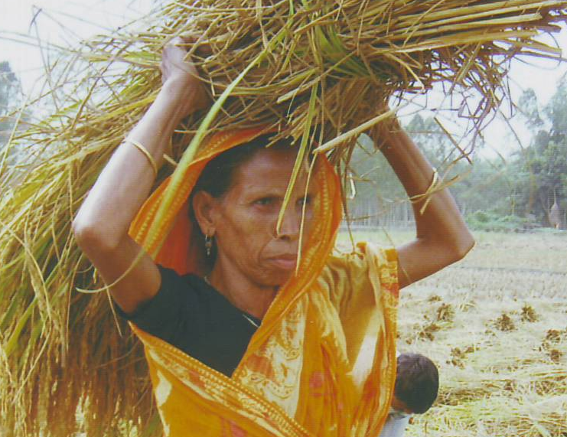

Nari Associate for Revival and Initiative (NARI)

Annual Progress Report
July 2010 to June 2011

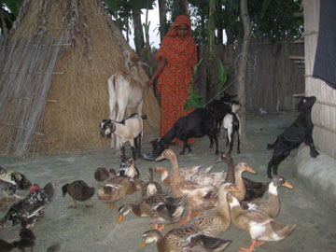
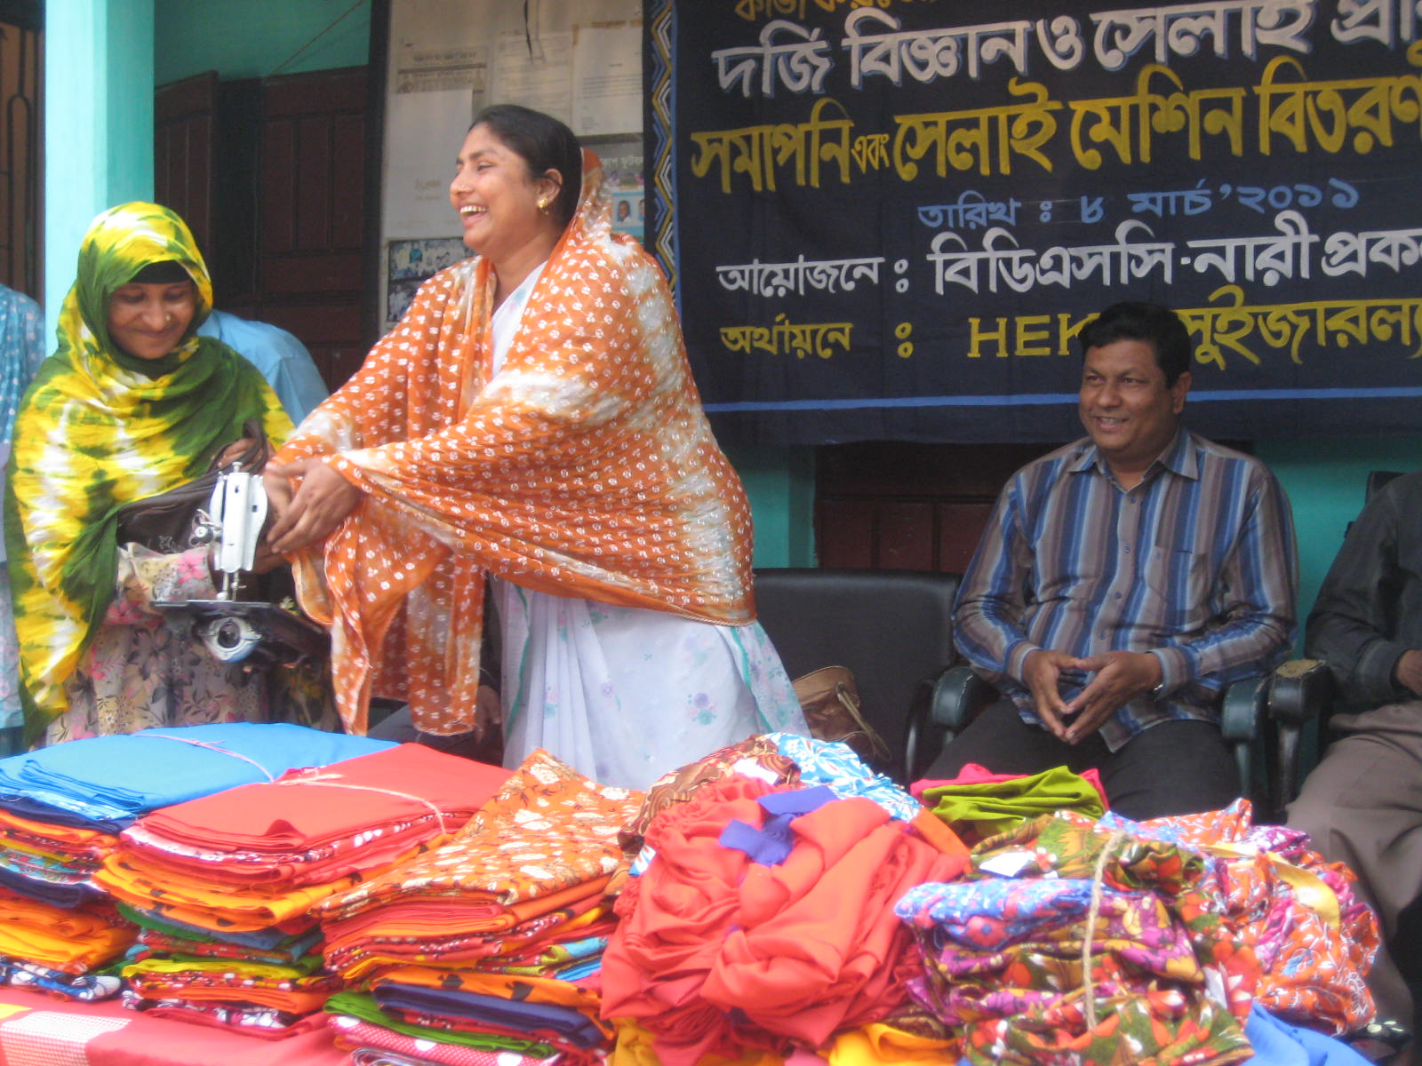
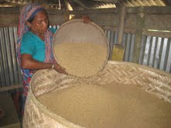
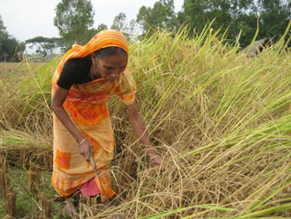
Submitted to:
HEKS-Switzerland
Zurich

Submitted by:
Bangladesh Development Service Center (BDSC)
House # 299/A, Road # 2
Baitul aman Housing society, Adabor, Shyamoly
Dhaka -1207, Bangladesh
Phone: 8121826, 8127226
E-mail: bdsc@bol-online.com

Contents: | Page
- A. Purpose of Report | 3
Overview of the Project: | 3
B. Addressees of the report | 4
C. Structure for the report | 4
1. General retrospect in the reporting period of the project area | 4
1. 1. Political main events in the project region | 4
1.2. Economical main events in the project region | 5
1.3. Sociological (cast/class/gender/religion) main event in the project region | 6
1.4. Other areas of general interest in the project region | 7
2. Activities of the organization in the reporting period | 8
- Main focus of the project work in 2008-2009 | 8 -16
2.2 Goals reached | 17
2.3 Goals not reached | 18
2.4. Main problems encountered | 18
- Audit observation and comments | 19-22
- Outlook of the organization for the coming year | 22
3.1 Main focus of the project work in 2010-2011 | 22
3.2. Action envisaged overcoming the problems (listed fewer than 2.4.) | 23
3.3 New/additional areas of activities taken up | 24
Annexes: | 25-44

Overview of Project:
Name of project | Nari Associate for Revival and Initiative (NARI) project
Location of project | Ulipur Upazila, Kurigram District
Implementing organisation | Bangladesh Development Service Center (BDSC)
Duration of project | July 2008 to June 2012
Total project budget | BDT 19,318,584
Annual project budget | BDT 5,127,035
Period of reporting | July-December 2010

1. Context:

1.1. Political Environment:
Political environment of Ulipur is not stable in regard to personal interest among the sub-group of the ruling party. Local government like Upazila Chairman is inactive due to lack of appropriate government policy. A tag of war situation in between local administration and the Upazila Chairman has been existed for long time. It was found that within the ruling party, exercising an unhealthy game of power. Meantime ruling party members showed procession against local administration.

All development activities of the Upazila are controlled by the ruling party in connection with its dishonest leaders. The local administration, govt. service providing department are also dominating by the ruling party. Every where corruption & partisan mentality occurred in distributing the Test Relief Projects and other different projects like – 100 days work project, Monga Eradication Project, VGD, VGD-UP, Old Aged Allowance Project, Divorced Women Allowance Project etc.

  - Economical Environment:
Ulipur Upazila of Kurigram district is one of the poorest areas in Bangladesh. During last six months, the economical condition of Ulipur has been improved due to free from natural calamity and bumper production of agricultural products. Hunger, so far no more today; people have ability to buy at least 2 clothes in a year. Numbers of school going children increased, Men from poor family may remain jobless some times but women are involving with some economical activities such as, cow, goat, poultry rearing; vegetable production; handicraft and many other small enterprises. Some NGOs are providing credit support for them. The farmers are getting satisfied price for their agricultural product. Besides these, different projects help the extreme poor family, like – 100 days work project, Monga Eradication Project, VGD, VGD-UP, Maternity Allowance Project, Old Aged Allowance Project, Divorced Women Allowance Project etc. These are created very positive impact of economy of Ulipur. Farmers are getting more benefit by growing jute this year as govt. has settled justified price of Jute. Due to subsidy for fertilizers farmers are getting increasing quantity of agricultural products through cultivating other crops like rice, vegetables etc. Government National Services Project, which has reduced the rate of unemployment in the area. Wages rate of man and women has increased at least by TK. 100 – 120 and TK. 60 – 70. Apparently, as a whole the economical condition of Ulipur is rising gradually.

  - Social Environment:
During last six months, with the combined efforts from NGOs, Local govt. Institute and Government, the situation of social environment of Ulipur has improved a little bit but it is still remained at frustrating stage. Due to poor economical condition and extreme poverty, the cases of family conflicts, divorces, women oppressions, child marriages etc. at Ulipur is still surviving importantly but the rate of frequency is reducing day by day. The main reasons of family crisis and incidence of women oppression are increasing as mainly unemployment of the male part and increasing degree of awareness of female sometime do not accepting by male counterparts. People of this area are naturally very calm in nature and are like to lead peaceful life. For many unavoidable reasons, they do complain/case against others at NGO office, police station or women affairs office but maximum cases are dismissed or solved through negotiation or by counseling. Alongside the road of embankment, males are often engaging in gambling and having addicted by narcotics, a considerable numbers of women are involving with unethical activities. At village court or arbitration council, often the victims are not getting the justice. Apart these, most of the time the police have to keeping mum due to political pressure which ultimately making irrational situation.

  - Security Environment:
The law and order situation of all over the country is not optimistic at all. The government does not establish an optimum secured environment. This is a most important drawback of the present regime of the ruling party. In this regard supports from ruling party are decreasing day by day. But significantly the law and enforcing situation of Ulipur is comparatively better then other parts of the country. As women are involving more in jobs which leads to increase of family income amazingly, the women oppression incidence is reducing immensely. Women rights are securing here more or less importantly.

  - Humanitarian Environment:
Humanitarian environment of a particular area is depending on social, economical, political situation and religious norms of the area. Considering those, Ulipur is comparatively poor area where education level of people is very low, proportionately awareness level is also very low. Mean while, with the combined efforts from governmental and NGOs, the situation is improving instantly. Ulipur has no communal problem. People of all religions are living with peaceful coexistence.

People of the areas are also not familiar with the legal issues in terms of getting free from any unlawful arrangements in the society. So, in order to protecting human rights, still there have huge limitations in the project area. It’s worthy to mention that some initiatives have been taken by the NGOs to increase awareness of the people regarding human rights and legal aspects.

  - Development Policies:
Roughly 75 per cent of poor people in Bangladesh live in rural areas and depend directly or indirectly on agriculture for their livelihoods. Agriculture accounts for more than 50 per cent of the country's available livelihood opportunities. Whilst its contribution to national GDP (around 20 per cent in 2005) is declining, agriculture is still vital for the sustainable reduction of poverty and hunger.

While the PRSP adopts a broader perspective to the development of agricultural and non-farm activities along with the development of private sector and SMEs activities, the National Food Policy (NFP) gives priority to policy options that involve synergetic effects on poverty and hunger alleviation along with greater targeting of the poor and the hungry.

1.7. Effects of Climate Change:
Bangladesh is a central point of reference for the injustice of climate change. Its per capita energy consumption is the equivalent to about one liter of oil per week, contributing a small fraction of 1% of global greenhouse gas emissions, yet the country is listed in numerous risk assessments as one of the most vulnerable in the world to the effects of climate change.
Rising sea levels threaten inundation and saline intrusion in the southern coastal region, the risk accentuated by prediction of greater cyclone intensity. In a climate pincer movement from the north, melting Himalayan glaciers may disrupt the flows of the three great rivers, first with excess flooding and eventually with diminished volume. Erratic monsoon patterns and longer periods of drought in the north complete the roll call of climate predictions for Bangladesh.

Kurigram is one of the most vulnerable areas in the context of climate change. There are 16 rivers across the Kurigram district flood and drought is very common for this area. So, people of this area are living in the threat of climate change hazard.

B. Addressees of the Report:
This report is prepared for HCO, HEKS Zurich, their board and back donors. BDSC hopes that the report would reflect a clear scenario about the project activities, progresses of project activities, prospects, challenges and future direction of the project.

C. Structure of the Report:
1. General retrospect in the reporting period of the project area:

  - Political main events in the project region:

  - Economical main events in the project region:

  - Sociological (cast/class/gender/religion) main event in the project region:

  - Other areas of general interest in the project region:

2. Activities of the organization in the reporting period:

Main focus of the project work in 2010-2011
The project work in 2010-2011 were concentrated to capacity building of the Poocs, impart various skill development training and make the project as a decent model in the sustainability context. So, all the project works were arranged to focusing the mentioned objectives, which contributes to achieve the project goal. Details of project activities are describe as below:

2.1. Orientation on preparing yearly action plan:
An orientation on “yearly action plan” development for the project’s relevant staff has been completed successfully. After the training course staffs were able to conduct, formulating yearly action plan by the participation of the group members.

  - Workshop on Issue base process development for the staff:
3 issue base process development workshops has held for the project’s staffs. The contents of those workshops were Family based project planning process, IGA follow-up process and literacy center development process etc.

  - Working Materials for the TBAs:
During this period we have distributed working materials (Bag, Cotton, Bled, Savlon etc.) for 18 TBAs. Upazala Health and Family planning Officer (UHFPO) were present in the occasion. The UHFPO also distributed the identity card to the TBAs for their recognition as trained TBAs.

  - Provide bi-monthly refreshers training to the TBAs on Health care and Delivery system:
There are 3 bi-monthly refreshers training were held to have a gradual up grading of skill and knowledge of TBAs. In those training mainly discussed the problems they faced during the work in the field and critically analyzed activities they performed in the months.

  - Monthly Weekly meeting for the project staff:
The staff meetings were held weekly and monthly basis with an aim to sharing success and problems stories and probable way out processes. Weekly meeting emphasized to collecting loan installment money of Nari revolving fund and in the monthly meetings put emphasize to the review the monthly progress report and planning of consecutive month. Total 16 weekly and 6 monthly meetings were held during this period.

People of our concern (Pooc):

  - Training for the UNEC members on account keeping:
To have a self help nature of a CBO it is mandatory that the people of the organization can do accounts related activities by themselves. In this respect project organized two training on accounts keeping where 42 participants of Union Nari Executive Committee (UNEC) members were participated. These trainings are emphases to easy accounts keeping procedures, budget preparation and management.

  - Adult/adolescent literacy center and training for teacher & staff:
Project participants were educated much in different socio economic aspects but lack of literacy they were unable to keep records or documents of their activities as well as can’t read those again. To eradicate the situation project arranged adolescent and adult literacy program for the members of nari project. In this respect 6 centers initiated in the project with 120 illiterate participants. The teachers and the supervisory staffs received training on education methods and utilization of education materials appropriately. During this period learner’s progress were remarkable.

  - Awareness discussion in the group meeting:
In the reporting period series of sessions conducted in the group meeting on different issues by the CDOs. During this period total 844 meetings were held and average 12.84 group members were present in those meeting.

  - Workshop on organizational and financial policy development for UPEC:
It was organized workshop on organizational and financial policy development for UPEC. The UPEC members were present in the workshop and contribute their valuable suggestion as well as actively participate to develop the policy. Now the NARI is following the policy to implementing their daily activities.

  - Review workshop on organizational and financial policy development for UNEC:
The organizational and financial policy development review workshops were held by the participation of Nari representatives through out reporting period. Through these workshops 6 (UNECs) organizational and financial policies reviewed and finalized with necessary amendment. it enhanced the organizational rules, regulation and strengthened cooperation among the members to performing their responsibilities.

  - Training on small trade/business for the Nari members:
The NARI project organized two training courses by the participation of 30 Nari members on small trade business. Through the training, participants were able to implement practical knowledge for developing small business more efficiently. After receiving training participants were able to handling their business and money more efficiently and for instance earning more money for their family.

  - Training on cow and goat rearing for the Nari members:
Two training courses were organized for 30 Nari members on cow/goat rearing and beef fattening. Upazilla livestock officer conducted the training courses as resource person. Through the training participants were able to use practical knowledge for cow and goat rearing and beef fattening more efficiently.

  - Training on diversified crop/vegetable cultivation for the Nari members:
One Training course was organized for 20 Nari members on diversified crop production including vegetable cultivation. Upazilla Agriculture officer conducted the training courses as resource person. This training course created opportunity to participants on receiving practical knowledge of cultivation of diversified crop/vegetable appropriately.

  - Training on poultry firming & rearing for paravat follow-up:
Nari project liked to create and upgrade a local level service provider namely the paravat for continuing supports in case of sickness of livestock and poultry birds in the rural setting. One training course was organized for 15 Nari members on poultry firming & rearing for paravat (Paravat is the vaccinator of poultry and livestock in the village level). Through the training participants were able to use practical knowledge on poultry firming & rearing efficiently.

  - Conduct training on tailoring by external trainer and provide sewing machine:
A two months long training course has organized for 12 Nari members on tailoring. External resource person is conducting the training course. Through the training participants will able to use practical knowledge of making of different kind of dresses efficiently. After receiving training every participant will get a Sewing Machine from Nari project and started their home based work which will enhance their dignity.

  - Organize sensitizing workshop at Union & Upazila level:
Therefore, three sensitizing workshops were organized with 150 participants at Union & Upazila by the participation of LEB, religious leaders, elites, GO and NGO officials. Through these workshops participants were understood about Nari project, its activities, progress, and problems and being social barriers. Thus a relationship has been built up in between Nari leaders and the dominant persons of the community. During the reporting period several family conflicts and social conflicts had been resolved in the local level.

  - Observance of national/international day at Union & Upazila level:
During the reporting period, Nari project organized 8 events for observed different national and international days at Union & Upazila level by the participation of 948 participants to have an aim to mobilize community people in line with the activities rendered by the project. The observed days were international AIDS day, international women day, Begum Rokey day etc. The days elaborated with the events of rally, discussion and folk songs. The Upazila administration, local elites, GOB & NGO officials, general peoples and the Nari members were attended on those occasions.

  - Periodical meeting with UPEC:
As per plan two meeting were held with UPEC by the participation of 35 members. Through this meeting the committee identifies the problem and prospect of the organization and solves it with participatory discussion. On the other hand the participants have able to develop themselves as a skill leader which will enhance the sustainability of the project.

  - Monthly UNEC meeting:
The Union Nari Executive Committee (UNEC) meetings were held monthly basis at 6 different UNEC by the participation of committee members. This committee is a powerful committee. The entire activities plan, plan of the project is implemented through the direct participation of these committee members. They were the representative of Nari prathomic Samiti (NPS). Total 30 meetings were held during this period and average 13.80 members were participated in each meeting.

  - Child to child and Adolescent group:
Child to child program is a unique program which likes to bring measurable behavioral changes among the children, family and community people especially on health and preventable diseases often occurring in the community. During the reporting period 42 Child to Child (CTC) groups and 30 adolescent groups were working by the participation of 1281children among them 840 are child and 441 adolescent girls. Fortnightly meeting were held individually among the CTC and adolescent. Main discussion issues were in the CTC groups; preventive health care, child rights and life skill education and in the adolescent groups; reproductive health, Denmohor, Marriage registration etc. through folk songs and drama.

  - Seed distribution of different crop:
Qualitative seeds of different crops distributed among the 564 Nari members for the winter season. This seeds were used for homestead gardening with an aim to improve the nutritional status as well as generation of income for Nari members.

  - IGA input support from NARI revolving fund:
The uprising nari revolving fund generated for income generating activities (IGAs) for Nari members. The Nari Executive Committee has opened a bank account in a nationalize bank with combined signature, two from Nari committee and the coordinator of Nari project. As per committee’s decision now up to TK. 20,000.00 loan can receive a member on the basis on her business plan. Present status of NARI revolving fun is principle amount BDT 2,736,000.00 and interest accumulated BDT 423,011.00, all together BDT 3,159,011.00. The Nari revolving fund is increasing day by day and it will be helped to create sustainable position of the NARI organization in future.

  - Loan distribution from savings fund of UNEC (Nari):
Every UNEC had individual savings account and they utilized their savings money as revolving credit among the members with 10% interest. In this process savings of nari members raised up to BDT 984,801.00 (for 6 UNEC) and interest accumulated BDT 177,999.00 up to December 31, 2010. The savings accounts were maintained by the UNEC in accordance with the savings policy of UNEC.

  - Monitoring and follow-up and internal evaluation:
Regular monitoring and follow-up and internal evaluation were conducted as per plan of action during this period. The management personnel i.e. Executive Director & Deputy Director involved in continuous monitoring of the activities of the project. It is done as monthly basis and provided their findings and suggestions for improving the activities. An internal evaluation was conducted at the end of the year (June 2010) by the Assistant Director of Research, M & E of BDSC. The findings were; the profession of women changed that in baseline house wife was 93% but in monitoring result is 94% involved with different IGAs. In the base line monthly income was above 2100, 5.83% and in monitoring result is 41.67%, 84% are changed their behavioral after involve with BDSC Nari project and 89% are developed after getting IGA supports.

  - Monthly and yearly report preparation:

Project staff prepared their report as monthly basis and submitted to the Project Coordinator (PC). The Project Coordinator compiled the entire report and sent it to head office of BDSC. The Deputy Director (DD) analyzed the report and sharing with the ED and provided necessary feedback to the PC for taking necessary corrective measures. At the end of the year DD prepared the annual report based on the field report and sent it to HEKS.

  - Goals reached:

Goals are the ultimate dream of a project. To reach in to goal needs to achieve some objectives. Practically project likes to achieve some predefined objectives. Objectives are more or less can be achieved with in a stipulated timeframe. If all objectives met successfully its completion criteria, so that it is expected that project fulfill some how of project goals. But naturally it is too difficult which needs some more time to achieve. As the project is related with many issues like social, economical and political activities, it is not easy to reach goals within the short stipulated time period. Of course, in the mean time, we could establish a platform for the CSW through which the project will therefore lead towards the goal in future. The NARI is an on going project and the reporting period is since the middle term of the project, this is too early to measuring the project goals. But, we can say that the project is in its track, as instance, some positive indicators are mentioned below:

2.2.1. 84% Nari members revived themselves through entering into social life by adopting alternative income generative activities of the project, on the other hand awareness boosted among most of the participants regarding training, social life with dignity and demerits/ illegitimacy of the current profession.

2.2.2. 89% participants now own some assets such as capital money, cows, lands, shops through usage of revolving grants of the project along with their own savings. These participants are now engaged in dealing various tiny businesses - rice husking, cloth business, tea stall, grocery shops, hawking business, bakery, restaurant, tree nursery and paddy cultivation, fisheries etc after receiving IGAs training and input support from BDSC.

2.2.3. The profession of women has enormously changed that in baseline data shows house wife was 93% but in monitoring result shows 94% involved with different IGAs. In the baseline data shows monthly income was above 2100, 5.83% and in monitoring result shows 41.67%.

2.2.4. 43 Groups of 600 members are feeling enthusiasm to improve their unity for achieving better life.

2.2.5. NARI women built a strong coordination with GO-NGOs, local government, police & judiciary, civil society and community through different workshops, meetings etc. It senses renewed social acceptance.

2.2.6. Nari members are significantly contributing to their families by providing financial support from their alternative incomes by leaving Sex Business and this enhances their moral matters involving in alternative profession.

3.1.7. Sensitization about the rights enhanced among the groups as they frequently raise their voice against the deprivation.

2.2.8. Group raised voices against family and social violence and increased capacity to take decisions in their united forum such as they solved about 15 cases regarding the violence against women. They are now playing also stubborn role in protecting early marriage and they protected 17 early marriages during reporting period.

2.2.9. Nari members are well aware to their children in schools as they perceive the importance of education

  - Goals not reached:

As it mentioned before that, during a certain time recognized goals may achieved partially. As we are now at the middle of the project period, the achievement yet we are needed to fulfill are given below:

2.3.1. Still 11% NARI participants are not involved with any IGAs activities, so the pace of rendering self employment among Nari member is not up to the optimum level. Moreover, the grants is also too little to run a business independently with a view to changing the days.

2.3.2. 16% of participants is still retaining with their previous sex profession.

2.3.3. Awareness on women rights, legal issues and gender sensitiveness boosted among the Nari participants but not in a sound level to protect them properly.

    - Social acceptance level doesn’t bear out favoring fully to the Nari participants, so still they are kept aloof from the mainstream process.

  - Main problem encountered:

During the implementation of the project, the organization faced some challenges/problems which hampered the progress of the project are as follows:

      - Bureaucratic problems lying at NGO Affairs Bureau, of which, hinders the smooth continuation of the project as it lingers the procedures issuing clearance for drawing funds from the banks.

- Less presence of the target beneficiaries in the group and UNEC (Union NARI Executive Committee) as they frequently engaged in seasonal works like: infrastructure development work (road improvement) by other NGOs or in international development projects (RDRS, CLP), agricultural labor work and national & Upazila elections.

- Different causes are functional among a small number of Nari members not to leave the sex profession fully i.e. social insecurity, absence of husband, physical needs, long habituation, social exclusion and stigma. These are still performing as a crucial problem to bring the Nari members to the mainstream from their previous profession, according as the field analysis reports.

- Some Nari members suffering for their husband behavior. Because, their husband is involved with gambling and destroy the money which is descend the family in suffering.

- Some Nari members are migrating seasonally and they do not establish their mind to a permanent IGA. So its makes vulnerability of those members.

  - Audit Observation and comments:

The observations and comments have been incorporated with the report from the Audit Observation Report during July 2009-June 2010. These are as below:
Observation -01

Vegetable Seed Master Roll:

During the course of our audit we have observed that Approval signature has not affixed some of the page in the Vegetable seeds distribution master roll. Such as:
Date | Area | Particulars
03. 10.2009 – 14.10.2009 | Pandul and Gunaigachh | Approval signature has not affixed in the Master roll.
Recommendation:

Approval signature must be affixed in the distribution Master roll and Management should take proper steps for this purposes.

Management Response:

Project Coordinator has not been checked and sign during the distribution period. Timely checking system should be applied for vegetable seeds distribution and other distribution purposes.

Observation -02

Stock Register Book:

During the course of our audit we have observed that Stock Register book has not been maintained for goods of stock (paper, pen, pencil, Khata and other stationeries).

Recommendation:

Stock Register should be maintained by the management for better management control.

Management Response:

For the Store room, separate Register book have to maintain by the management and checking, balancing column should be maintained.
Observation -03

Assets Register Book:

During the course of our audit we have observed that Asset Register book has maintained but Photocopy machine (as per Register 1 piece but actual quantity was nil) have not found in the Project office when we have completed assets verification.

Recommendation:

As per Asset Register quantity and physical quantity should be same and any difference should not be allowed for the Project.

Management Response:

BDSC, Ulipur management has been acknowledged that Photocopy machine use is in the Dhaka head office.

Observation -04

Log Book:

During the course of our audit we have observed that separate Log book has not been found for Motor cycle fuel purchases purposes.

Recommendation:

Management should consider keeping and updating Logbook.

Management Response:

Logbook maintaining is mandatory when riding motorbike. So, BDSC management instant orders to project office in this issue. Already vehicle number has mentioned on the bill/ vouchers and rectified the above mistake.

Observation -05

Approved By Signature:

During the course of our audit we have observed that Approved by signature has not been attached in the main voucher and supporting voucher. Such as:

Date | Vr. No. | Amount | Head of A/c | Particulars
11.05.2010 | 524 (Dr.) | 1,128.00 | Recurring Expenses | Approved by signature has not been attached in the voucher.

Recommendation:

Approved by signature must be attached in the bill/ voucher. Management should be take proper steps for this purpose.

Management Response:

Checking system should be strong for such mistake and duly checked should be confirm by the Project Coordinator (BDSC –NARI Project, Ulipur, Kurigram.)
Observation -06

Program Cost:

During the course of our audit we have observed that Program Cost for develop small firm and cow rearing purposes separate name has been referred but separate amount in Tk. has not been referred in the Voucher and other related documents. Such as:

Date | Vr. No. | Name of the Beneficiaries | Amount in Tk. | Head of Account
14.06.2010 | 584 (Dr.) | (i) Mrs. Lebu Begum  (ii) Mrs. Adori Begum  (iii) Mrs. Rabeya Begum | 50,000.00 | Program Cost

Recommendation:

Name wise amount in taka should be referred in the voucher and other related documents and management should be take proper steps for this purpose.

Management Response:

Joint purposes program has been operated by these beneficiaries and total taka invested for one joint firm under these beneficiaries for this reason total amount in taka has not been separated.

Observation -07

Supporting Voucher:

During the course of our audit we have observed that supporting voucher has not been affixed with main voucher. Such as:

Date | Vr. No. | Amount in Tk. | Head of A/c | Particulars
13.06.2010 | 580 (Dr.) | 200.00 | Motor cycle fuel expenses | Motor cycle fuel expenses but supporting voucher has not been affixed with main voucher.

Recommendation:

Supporting voucher must be affixed with main voucher and management should be take proper steps for this purposes.

Management Response:

Fuel cost purposes this amount has been taken as advance so supporting voucher has not been affixed in this matter. After expenditure that supporting voucher has been maintained separately and balance in taka has been adjusted after occurred this expenses.

Observation -08

Budgeting Head:

During the course of our audit we have observed that actual expenditure has not been found though budgeted amount has been Tk. 120,000.00 for the head of “Higher training out/inside of the country”.

Recommendation:

Actual expenditure figure should be expended approximately of budget figure and such difference should not be allowed in any way and management should be take proper steps for this purposes.

Management Response:

For fund crisis budgeted amount has not been expended and generally budget prepared as estimated but expenses incurred actually. This matter already been approved by the BDSC management.

Observation -09

Budget variance:

In some cases have exceeded budget provisions. And some instances are as follows:

Head of Accounts | Approved Budget | Expenses
Photocopy & Supplies | 18,000.00 | 21,824.00
Entertainment | 12,000.00 | 13,452.00
Reporting | 12,000.00 | 13,916.00

Recommendation:

It is necessary to consider budget line expenses for any type of program activities. If exceed budget line then proper documentation should be kept.

Management Response:

Generally budget prepared as estimated but expenses incurred actually. For this reason some budget line items have been exceeds and some budget line have been less considering total budget. Excess expenses already been approved by the BDSC management.

- Outlook of the organization for the coming year:

  - Main focus of the project work in 2010-2011:

After having experience from the previous implementing period, BDSC has planned to focus on some issues that are essential to be addressed for the sustainable development of the beneficiaries of NARI project. The following are some of them that have been planned to be addressed in the coming period:

    - Special emphasis given to enhance the basic education of the Nari members in a view to boosting their knowledge to deal the trivial issues in daily life.
    - Published case study about program success and arrange dissemination seminar in Dhaka for like minded organizations and donor agencies.
    - Continue the advocacy activities at different levels of policy makers, civil society and other stakeholders for sensitization in favor of bringing better life of Nari members.
    - Strengthening Upazila Executive Committee (UPEC) through developing some pragmatic rules, policies, strategy and norms.
    - Continue livelihood improvement of the beneficiaries through providing skill development training on different trades i.e. training on Small firm management (Cow, Goat, Sheep), pond management & Carpentry etc. so that they can lead a normal and safe social life with human dignity.
    - Continue increase awareness among CSWs on their rights they deserve and legal aids on different legal issues.
    - Continue creation of alternative employment through increasing IGAs training for their self reliance.
    - Exposure visit will be arranged for gathering knowledge from others self-help organization.
    - Amount of financial inputs support will be increased to strengthen their little business for self-employment.

  - Action envisaged overcoming the problems (listed under 2.4.):

      - Bureaucratic problems lying at NGO Affairs Bureau, is a normal phenomenon in our country. To smooth continuation of the project activities, organization has provided temporary loan from their general fund.

- Emphasized on strengthening the own institutions through boosting capacity among the Nari members with fine tuning of project activities as well as setting the standards of rules and norms.

- Interpersonal communication has been strengthened through the advocacy activities to build the strong relationship with the Nari members as well as community members for influencing them bringing into mainstream social process.

- Local influential persons have been involved as a change maker and they were motivated to participate with the project as a sacred work.

- Due to illiteracy of the Nari members, as per their skill, IGA was selected for them more practically; this helped them to create long term employment generation.

- Enhancement of activities for alternative income sources for the Nari members in a view to boosting their self reliance and keeping them in the ambit of the project.

- More highlighted on magnitude of negative ness of sex business issue through awareness raising and continuous interventions of the project activities.

  - New/additional areas of activities taken up:

- Nari project is going to establish an own business center at Ulipur Upazila town where they open show room/Hotel/restaurant for selling their own products.
    - Incorporate a new idea to developed family business, where all family members will be involved for planning and implementation of a tiny business.
- Strengthen cooperation with the Department of Women and Child Affairs, Law enforcing agencies, Lawyers, Department of Education, Department of Health and Family Planning and other NGOs working with the similar target beneficiaries.

In the mean time, the project has been able to draw attention of different level stakeholders that is very much important to accelerate the project activities and sustain the development of the target beneficiaries.

