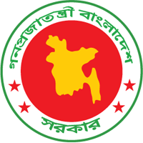
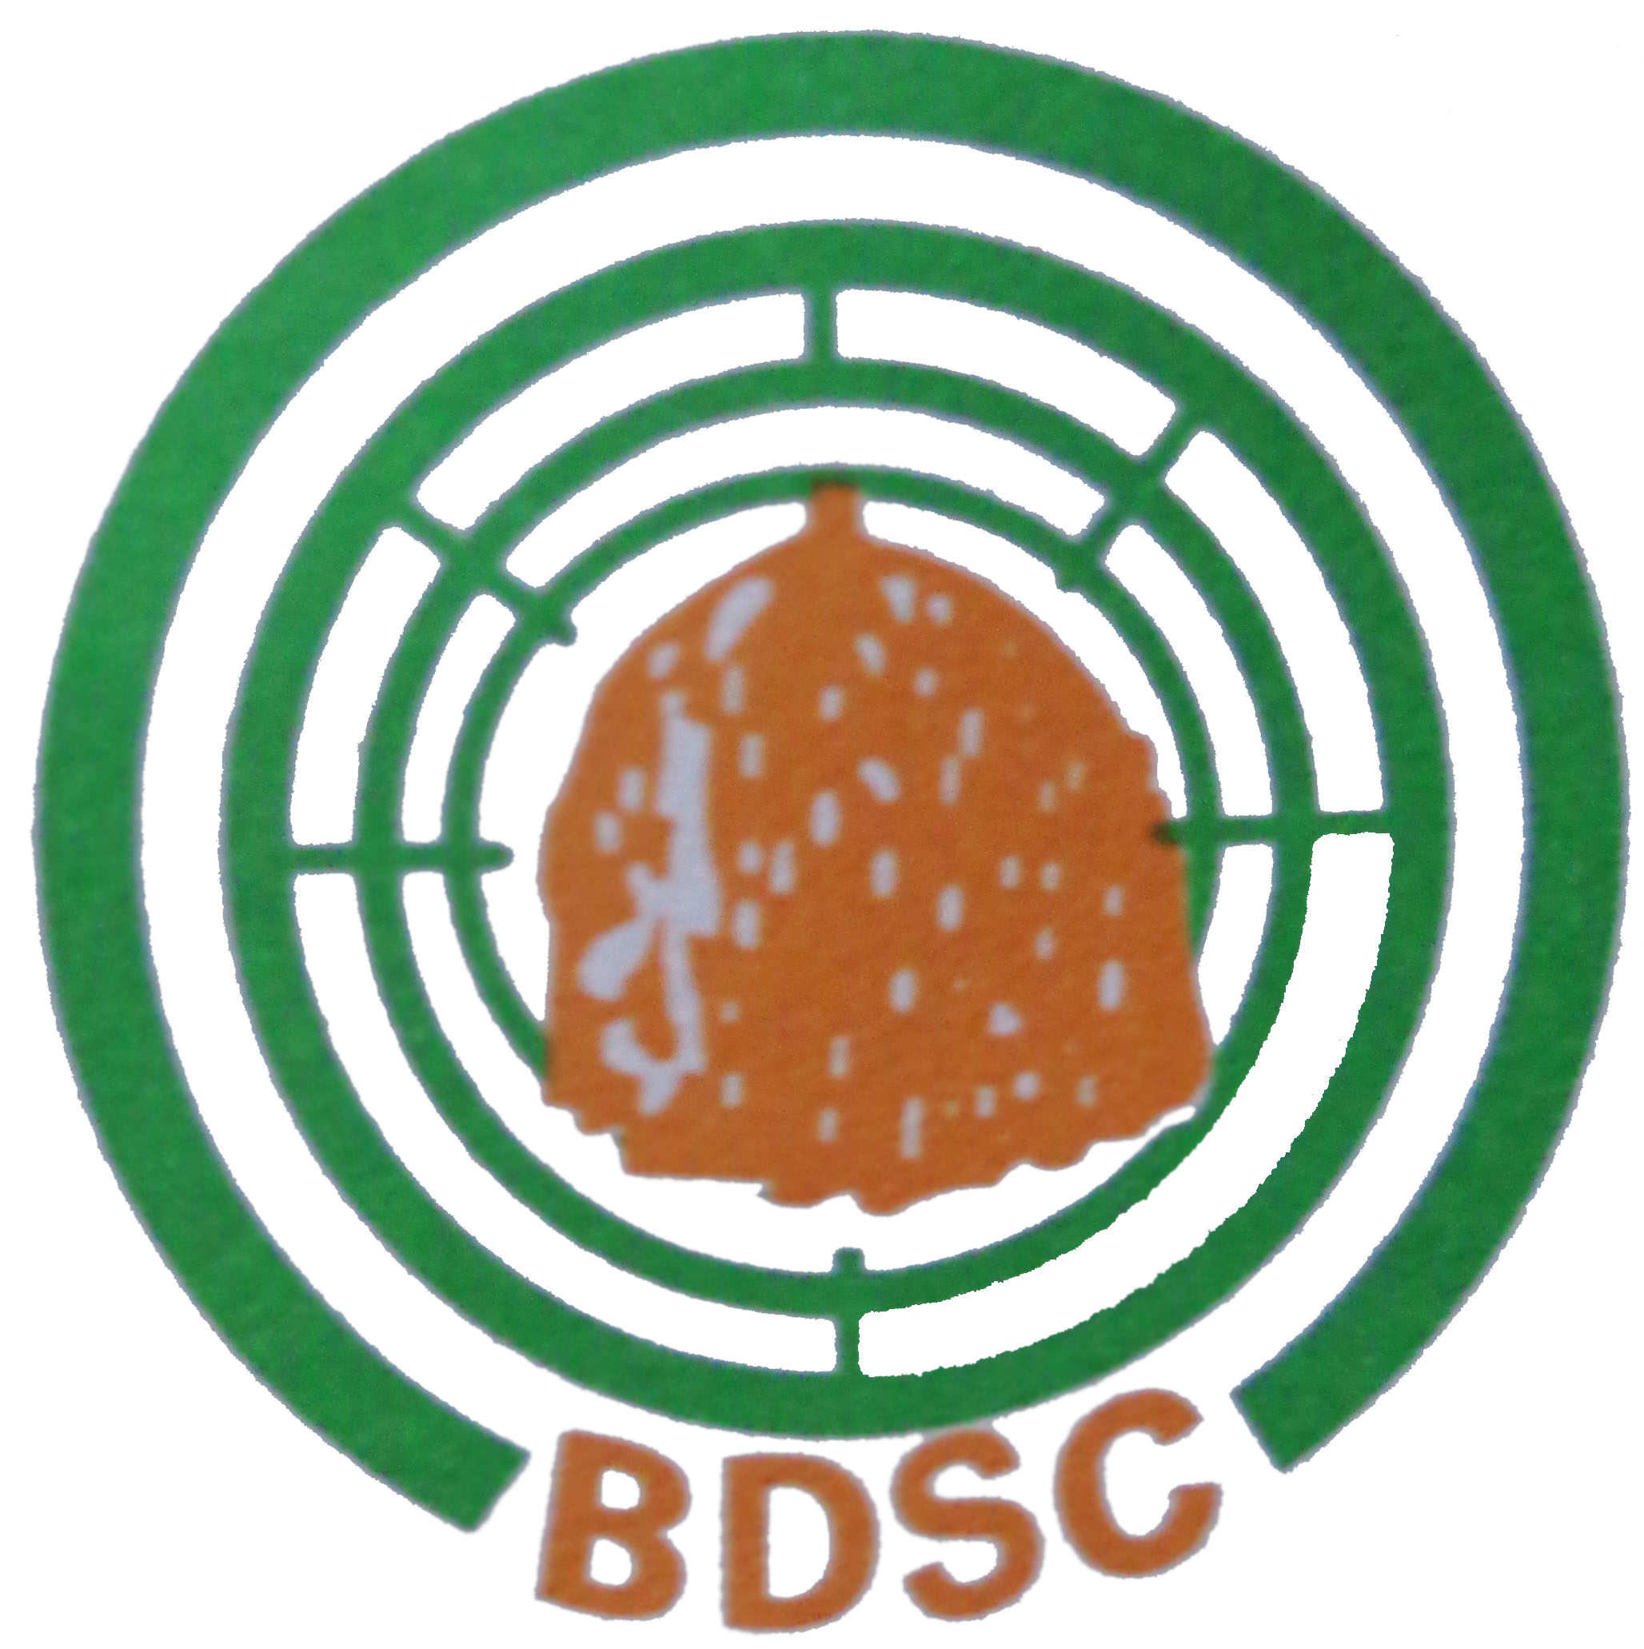

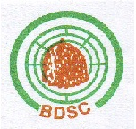
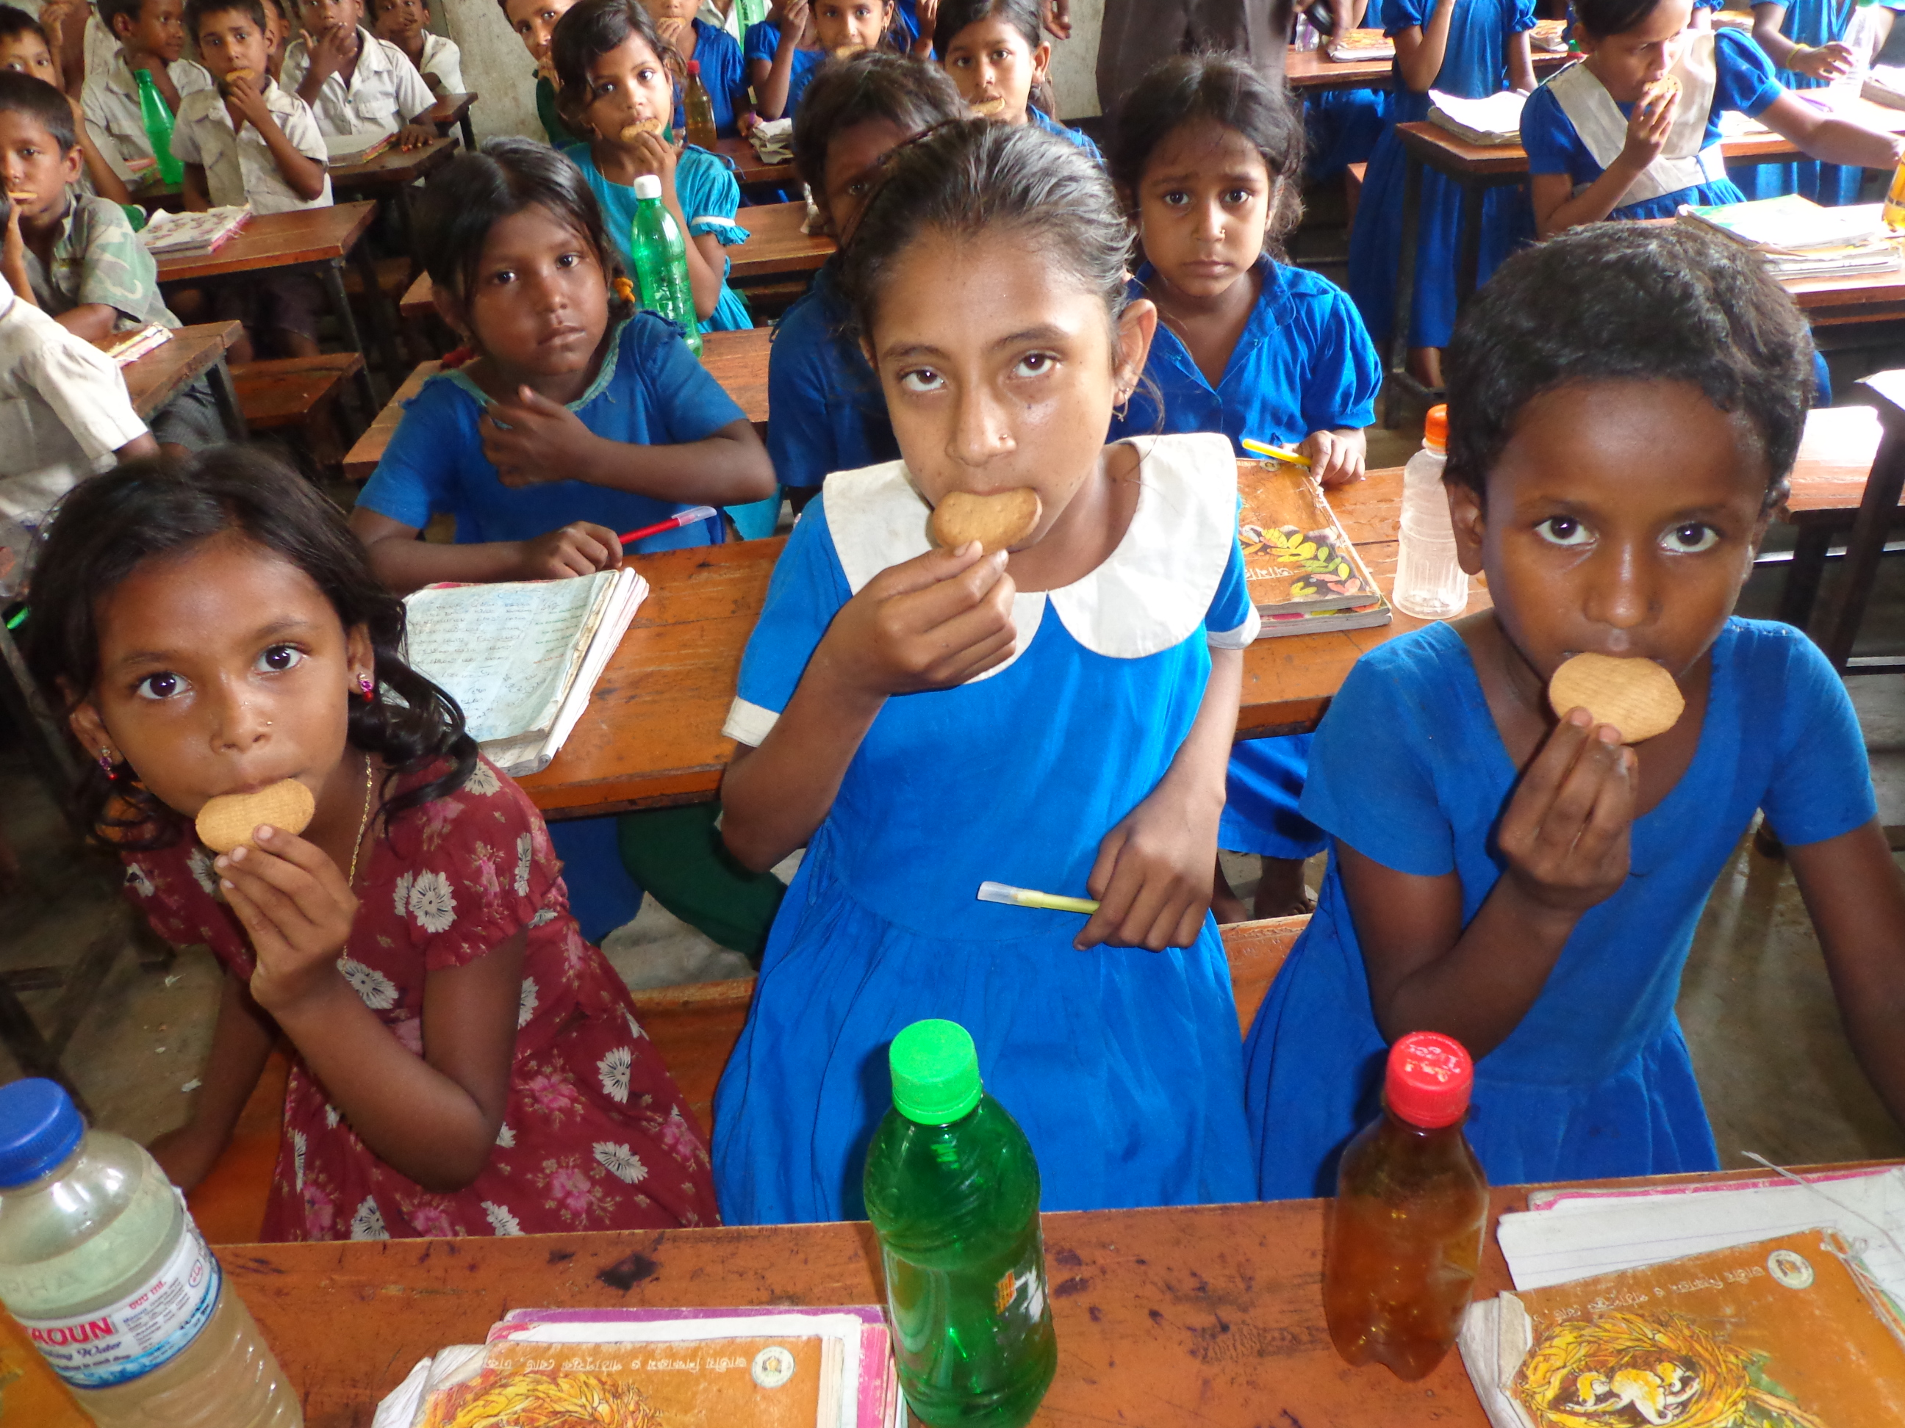
Project Progress Report up to contract period | School Feeding Programme  Duration January 2011- November 15, 2015

Submitted to:
Project Director,
EU Assisted School Feeding Programme
Directorate of Primary Education
Room # 112, Section-2, Mirpur
Dhaka-1216
Bangladesh Development Service Center (BDSC)
House # 298 ,Road # 2
Baitul Aman Housing Society
Adabor, Shyamoli, Dhaka-1207.

Tel: 8121826, 8127226
E-mail: bdsc@bol-online.com
www. bdscbd.org
Table of Content
# | Subject | Page
 | Acronyms | 2
01 | Introduction | 3
02 | About Contract | 5
a | Amount of money ( Financial progress): | 5
b | Quantity/Volume of work ( Technical progress | 5-6
c | Contract period | 6
03 | Activities – for factory | 6
a | Elements of biscuits, Sources of raw materials, Quality Control of fortified biscuits | 7
b | System of Production and Supply for fortified biscuits | 7
c | Receipts and Distribution of fortified biscuits and distribution procedure (For NGO) | 7-10
04 | Programme | 10
a | Different Programme performed by NGOs / Factories with pictures | 11-14
b | Comparison of student’s different data between 2010 & 2015 | 14
05 | Comments (Positive attitude) if any (may be visitor’s comments about your factory or NGO office)  [[ | 15
06 | Conclusion | 15

ACRONYMS
APD | Assistant Project Director
BDSC | Bangladesh Development Service Center
DPE | Directorate of Primary Education
EU | European Union
GoB | Government of Bangladesh
HEB | High Energy Biscuit
MDG | Millennium Development Goal
NGO | Non Government Organization
PD | Project Director
SFP | School Feeding Programme
SMC | School managing committee
UNO | Upazilla Nirbahi Officer
UP | Union Parishad
WFP | World Food Programme

01.Introduction ( about factory / NGO):
Bangladesh Development Service Center (BDSC) was established in 1978 as a National Non-Government Organization. It is a non-profitable and non-political organization that has been working to build a just and equitable society. It has started its voyage by rendering capacity building training of different NGOs those were exclusively engaged in implementing development program activities around the marginalized people in the rural areas. Subsequently, the organization moved towards the development of the marginalized people through initiating program activities on literacy, public health, awareness raising, skill development, gender development, reduce food insecurity income generating activities etc. by itself.
Brother Raymond Cournoyer, a devoted social worker hailed from Canada and Dr. M. Mohsin Ali, a committed social worker jointly initiated to form an organization that was named as BDSC later on with the direct involvement of renowned Professor Dr. Muhammad Yunus, of Grameen Bank, Professor Dr. M. A. Hamid, former vice-chancellor, Islamic University, Ms. Taherunnesha Abdullah, and National WID Consultant. At the very beginning of the organization when BDSC revealed it’s skill through imparting training, CUSO (Canadian University Services Overseas) and Inter Pares of Canada came forward for funding the organization in order to improve the socio-economic condition of the assetless, vulnerable and distress population with special emphasis on women and children development through the NGOs to whom BDSC used to render training. Since then, BDSC has been continuing development work with the fund of more than 40 donors (both of foreign and GOB) and has been engaged itself in dragging out the extreme poor people to change their fate with its’ multidimensional activities.
BDSC is one of the pioneering organization in Bangladesh has been working in the field of non formal education and skill based education. It was worked with UNICEF, ADB, GoB WFP funded different education projects in different locations of country from its inception.

With the financial and technical assistance from European Commission, BDSC implemented School Feeding Programme at Dharamapasha upazilla in Sunamgonj district and Lakhai upazila in Hobigonj district. The project covered of 149 Government Primary Schools of both the Upazilas (98 govt. primary schools at Dharampasha upazila in Sunamgonj district and 51 govt. primary schools at Lakhai upazila in Hobigonj district) with the involvement of multiple stakeholders including primary school students and their parents/guardians, school teachers, School Management Committee (SMC), Union Parishad (UP), upazilla and district level officials of the education department, policy makers of the education sector and the contractor for supplying the biscuits. The direct beneficiaries or the target groups of the project were a total of 51,853 students from 149 government primary schools. The main purpose of this project was to contribute to the achievement of MDG-2 by improving the food security of the poor and ultra poor children of the targeted area, through distribution of fortified biscuits and accessing them to quality primary education. Other purposes of the project was to ensure the access of the children to the full course of primary education and to improve the nutritional status of the school children by accessing them to dietary food, with the special emphasis on the poor and ultra poor children.

As per design of the project, at the end of the stipulated period, the project achieved three results including i) enrolment, attendance and completion rates at the primary level of education increased by enhancing learning capability and more attentiveness towards studies of primary education institutions in selected areas by supplying fortified biscuits and by increasing the nutritional status of primary school students; ii) the community and school authorities proactively contributed to address the issues related to education, health, hygiene, sanitation, nutrition, gender issues, and disaster risk reduction that have the positive impact on enhancing the quality of primary education.

Key stakeholders: 51,853 students of Sylhet region including 23,277 from 51 government primary schools of Lakhai Upazila under Hobigonj district and 28,576 from 98 government primary schools of Dharmopasha Upazila of Sunamgonj district.

Upazila wise student information:
Name of District/s | Name of Upazila/s | Total number of Students
Sunamgonj | Dharampasha upazila | 28,576
Hobigonj | Lakhai upazila | 23,277
Total |  | 51,853

At Dharmapasha upazila of Sunamgonj district, a total of 28,576 students and at Lakhai upazila of Hobigonj district , a total of 23277 student received the food assistance during the project period. A total of 51853 students from both districts and upazilas were entitled for the assistance from project.
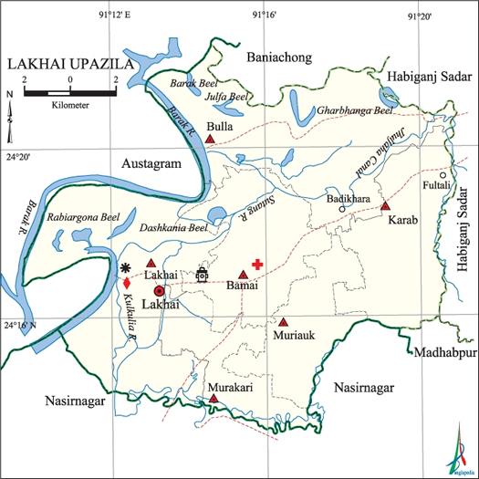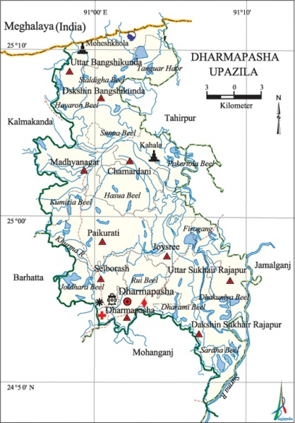
Geographic Locations of the Project

02. About Contract

(a)Amount of money (Financial progress):

A total of BDT 32,114,533

(b) Quantity/Volume of work (Technical progress):

The implemented activities during the implementation period were contributing towards the achievement of the overall and specific objectives of the project. As part of proper implementation of the project, within the implementation period, with the participation of 100% of 149 schools teachers. Meetings with the School Management Committees (SMCs) of 149 targeted primary schools were also held by the project team that contributed a lot to implement the project towards the achievement of the project. To ensure the proper distribution of the biscuits, a plan for implantation of the project were prepared including collection, storage and distribution of biscuits for each of 149 selected schools. It is matter of pleasure that the storages/warehouses established within the campus of 149 primary schools were properly maintained by the school management committee. Secondary transport and distribution from warehouse to final delivery point was ensured. During the implementation time, fortified biscuits were transported using locally available vehicles as rental basis. The collected foods are stored for the period of one month up to receiving the biscuits for the next month. As per quality controlling measure, regular checking of the biscuits was ensured by the Warehouse Keeper. BDSC also assisted the proper storage of the biscuits for maintaining the quality in all 149 primary schools. Within the implementation time of the project, during each school day, on an average 51,853 students of 149 beneficiary schools got daily snack in the form of a 75 gm packet of fortified or nutrient enriched biscuits at 450 kcal/100 gm. Reaching the biscuits to the intended beneficiaries with free-of-charge, quickly and in good condition was a challenge for the project and BDSC has been doing the same accordingly since the beginning of the project. To ensure the quick distribution of quality biscuits with free-of-charge, the project operational team developed a robust monitoring system. All these performed activities were contributed to the achievement of result-01.

The progress of the project year was also very encouraging particularly in terms of school attendance and enrolment. The assessment is showing that the executed activities were successfully contributing towards the achievement of the resulit-02. The people of the targeted areas of 149 primary schools, mostly the parents and school authorities were proactively contributed to address the issues related to education, health, hygiene, sanitation, nutrition, gender issues, and disaster risk reduction that had the positive impact on enhancing the quality of primary education. The de-worming camps organized under the action positively changed the knowledge, attitude and practices of the parents and they were more aware about the treatment of worm infestation and the hand washing campaign was positively changed hand washing behavior.

The project team regularly carried out follow up activities and additionally, Programme Division of BDSC Head office also undertook regular follow up and internal evaluation of the project activities in collaboration with the respective primary schools and SMC. Programme Division of BDSC collected monthly/ quarterly reports about the progress of the activities.

The target groups covered under this action was a total of 51,853 students of Sylhet region including 23,277 from 51 government primary schools of Lakhai Upazila under Hobigonj district and 28,576 from 98 government primary schools of Dharmopasha Upazila of Sunamgonj district. PD of SFP visited a school at Dharampasha in Sunamgonj Significant portion of target students of Lakhai Upazilla belonged to poor families and on the other hand, significant portion of students of Dharmopash Upazila belonged to very poor Haor communities. Similarly, the final beneficiaries were about 55,000 parents/guardians of the said students which included very poor community members from backward, poverty-stricken Haor (low water logging areas) area of Sunamgonj district and economically very poor community members of Hobigonj district.

Following were recipients and distributed fortified biscuits during the project tenure;
Name of Upazila | Total received (cartons) | Total delivery (cartons)
Dharamapasha | 1,35,901 | 1,35,901
Lakhai | 1,13,176 | 1,13,176

(c)Contract period:

1st January 2011- November 15, 2015

03. Activities- For factory-
N.A
(a)Elements of biscuits, Sources of raw materials, Quality Control of fortified biscuits.
N.A
(b)System of Production and Supply for fortified biscuits
N.A
(c) Receipts and Distribution of fortified biscuits and distribution procedure (For NGO)

BDSC established two warehouses, one in Dharampasha upazila in Sunamgonj district and another in Bullabazar at Lakhai Upazila under Hobigonj district. BDSC prepared the warehouse as per EC guideline. Nabisco biscuit factory delivered the fortified biscuit as per requirement of our respective warehouse. BDSC distributed the biscuit in the govt. primary school at Dharampasha upazila in Sunamgonj district and also distributed the biscuit in the govt. primary school at Lakhai Upazila under Hobigonj district.
[ | [[[
  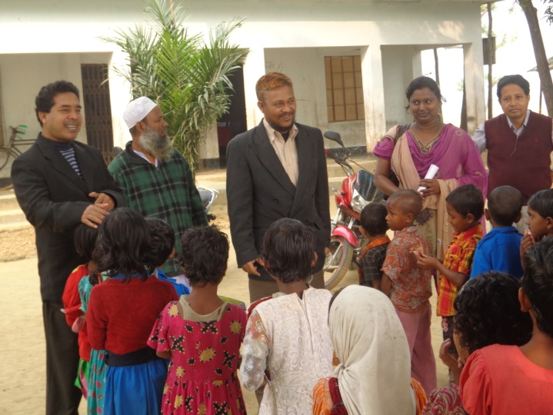[ |  | 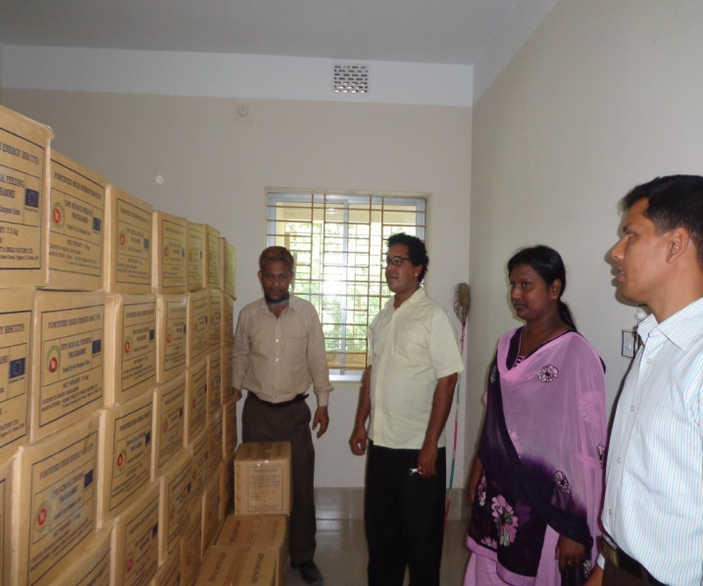[
  Official from PD office observed the biscuit distribution |  | APD of SFP visited warehouse at Dharampasha
Ensure Secondary transport and deliver warehouse to final delivery point (FDP)
The programme implemented under the GOB assisted school feeding programme with the Directorate of Primary Education supported by European Union. The Directorate of Primary Education selected 50,818 students of 149 Govt. Primary schools. This programme was food grain aid, so main responsibilities of BDSC were to ensure security and maintain quality of High Energy Biscuit (HEB). In order to maintain security and quality, BDSC established warehouses at Dharampasha Upazila in Sunamgonj district and Lakhai upazila in Hobigonj district with the fulfillment of characteristics of warehouse management guideline.
BDSC received HEB from selected vendor (Nabisco Biscuit Factory). During receiving biscuit the Storekeeper checked the biscuit cartoon and verified the quality and quantity of biscuit. He also verified the production order number, manufacturing and expiry date. The cartoon of biscuit was storage according to warehouse management guideline and the Storekeeper compared the amount of received biscuit with the challan of the vendor. He then acknowledged the challan and returned one copy and received 2 copies challan from the vendor.

Delivery Chain of fortified Biscuit:
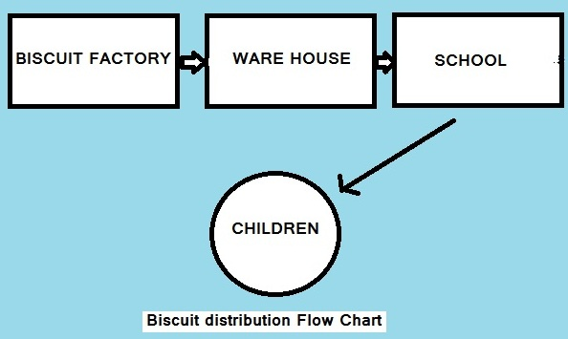

Organize distribution of biscuit in selected school:
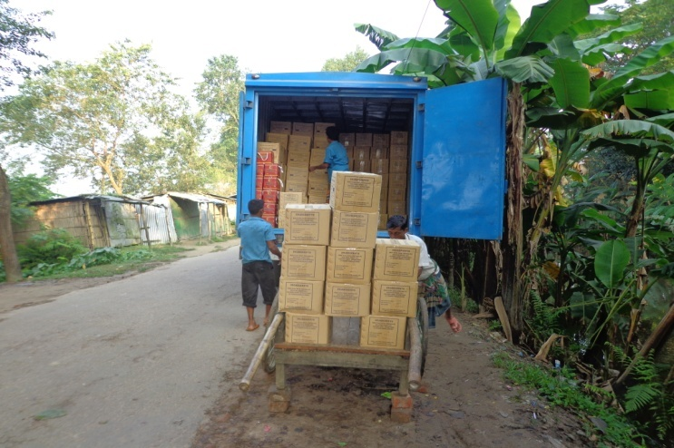  [ |  | 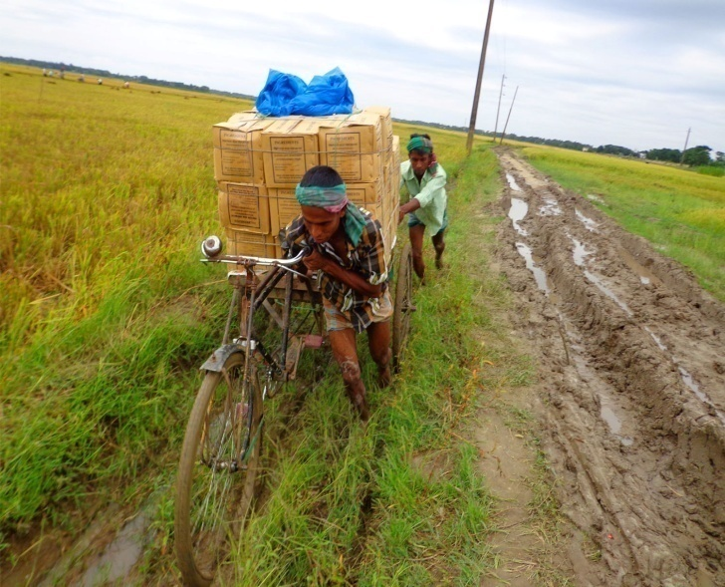  [
Biscuit Cartons unloaded from covered Van of Nabisco Biscuit Factory |  | Caring cartons for Govt. primary school from of BDSC’s warehouse
BDSC has recruited educated, experienced and skilled staff as Food distributor to ensure proper distribution. They delivered biscuit from warehouse to selected school. The head teacher of the respective school was the overall responsible to ensure proper storage and distribution. Under the guideline of programme, class teacher distributed it at the beginning of the class and ensured that the children drink sufficient safe drinking water. After taking the biscuit, the class teacher also ensured 100% consumption of distributed biscuit in school time with hygiene manner. The class teacher maintained daily biscuit distribution. The head teacher was responsible to prepare monthly utilization report through prescribed monthly utilization format.

From the project period distributed following quantity of fortified biscuits;
EU
Area | Received | Distributed
Dharmapasha | 202136 cartons | 202136 cartons
Lakhai | 174515 cartons | 174515 cartons
GoB
Dharmapasha | 67376 cartons | 67376 cartons
Lakhai | 25370 cartons | 25370 cartons
Total | 469397 cartons | 469397 cartons

04.Programme-

During the timeframe of the project, BDSC maintained all prerequisites of the project in order to well off completion of the project. From the inception of the project BDSC accomplished some other activities which were boosted up the school feeding program significantly. The activities were vegetable and kitchen gardening, SMC meeting conduction, awareness and community mobilization activities etc. Following are the brief description of those activities.

(a) Different Programme performed by NGOs / Factories with pictures

During the timeframe BDSC with the supports of all stakeholders completed different activities which helped to enhance students and their family members’ awareness on necessity of education, taking necessary nutrition and made all responsible on acquiring education for betterment of life. BDSC accomplished following activities in addition to direct biscuits distribution.
School vegetable gardening and Kitchen Garden:
With the consultation of the teachers and School Management Committees, BDSC established school vegetable gardens in 98 government primary school and also distributed seeds for kitchen garden among the students in Dharampasha upazila in Sunamgonj district. The Vegetable gardening idea ultimately created much interest and enthusiasm among the children. The children learned sustainable agriculture practices, how to use limited space, rotate variety of vegetable and possible methods for pest control. In Lakhai Upazila under Hobigonj district school vegetable gardens (51 gardens) established in every school premises and seed distribution among the students ensured for kitchen gardening.
Not only fortified biscuit increasing nutrition value of the students but also another idea was applied in field for increasing nutrition of the students. The school garden and kitchen garden was also increased nutrition not only for children. It also became an innovative idea to increase nutrition value for whole family.
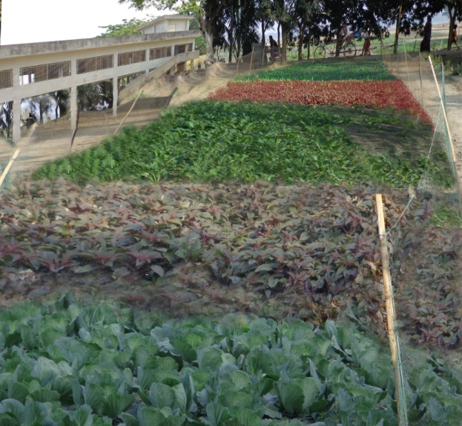 | 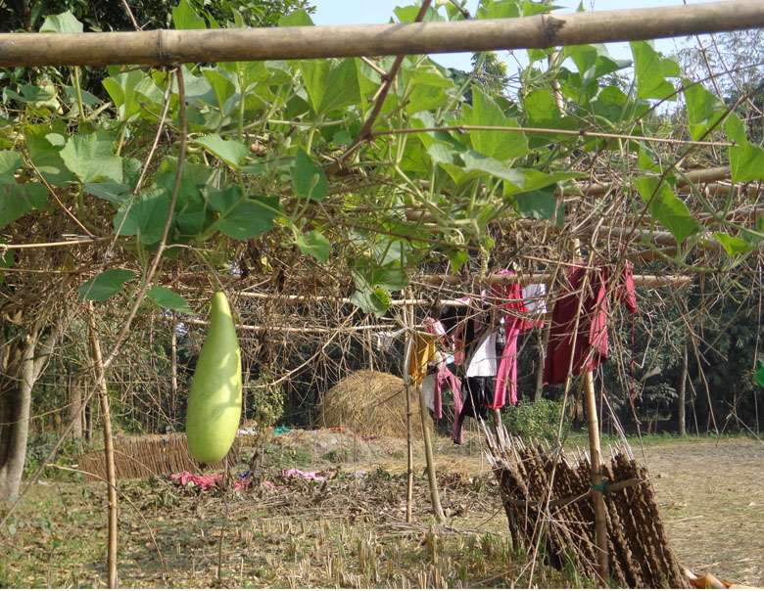
School Vegetable Gardens at school premises[[ | Kitchen Garden  [[
Students arranged their homestead garden. In our observation they were motivated for gardening at home and already they created their kitchen garden at their household.
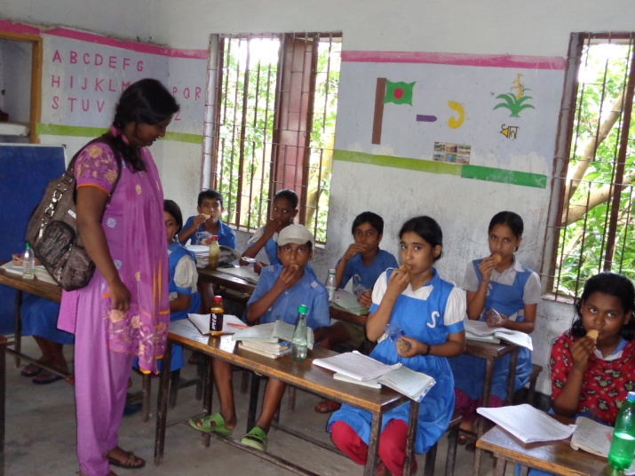[
Upazila manager visiting a school
Awareness and Mobilization Activities:
Local communities were not aware of education, health, hygiene, sanitation, nutrition, gender issues, disaster risk reduction and so on. We arranged issue based meeting on health, hygiene, sanitation, nutrition, gender issues, and disaster risk reduction. In Hobigonj district at Lakhai upazila, we arranged 2,323 issues based sessions and at Dharampasha upazila in Sunamgonj district arranged 3,228 sessions among the beneficiaries.

Cooperation with local Administration:
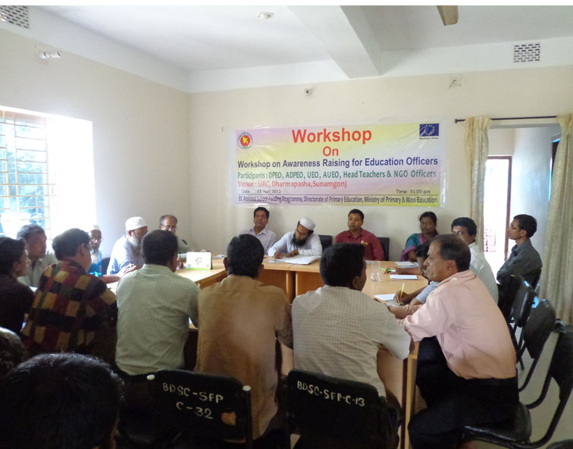
BDSC maintained close coordination with PD office, DPEO office, UEO office, SMC and other relevant stakeholders for smoothly operation the programme. Upazila Manager (UM) maintained communication with DPEO, UEO and AUEO and dissemination information with them regularly and gets feedback from them and also takes action in the field on the basis of their observation.
APD of SFP delivers his speech in a workshop
Our field staffs also established good relationship with the teachers, local government, SMC members, and guardians for implementing this programme in project areas. One of the positive signs that we observed every student washed their hand before eating biscuits.
Facilitated staff training on project concept: BDSC organized refresher training courses for their staff members on project goal, objectives, approaches, targeted students etc. of the action. BDSC oriented the staffs in brief for one day. The SFP Project Coordinator of BDSC was present as facilitator during the courses. Additionally all staff received guideline on vegetable and kitchen gardening.
Facilitated monthly & quarterly Staff coordination Meeting:
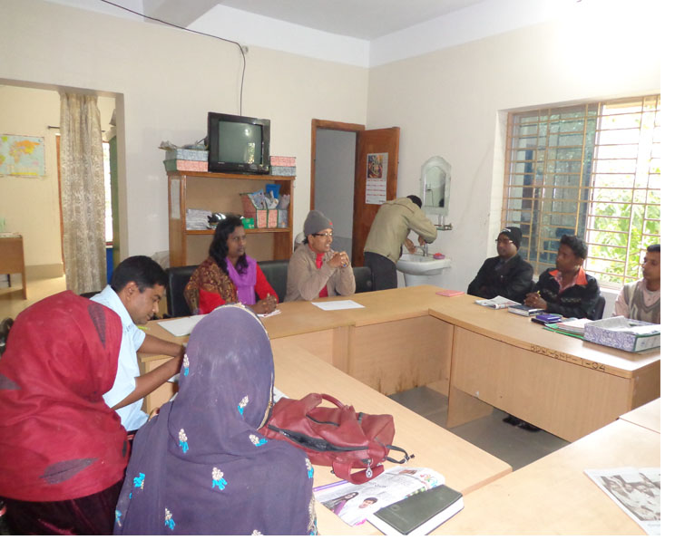
BDSC organized coordination meetings at Dharmapasha and Lakhai upazila. Major agenda of that meeting were progress of project update, Biscuit distribution, Biscuit distribution follow up, problems & findings, report collection, biscuit transport, vegetable gardening, kitchen gardening, quarterly SMC Meeting, financial & administrative issues and issue based discussion etc.
Monthly Staff coordination Meeting
Field Monitoring:
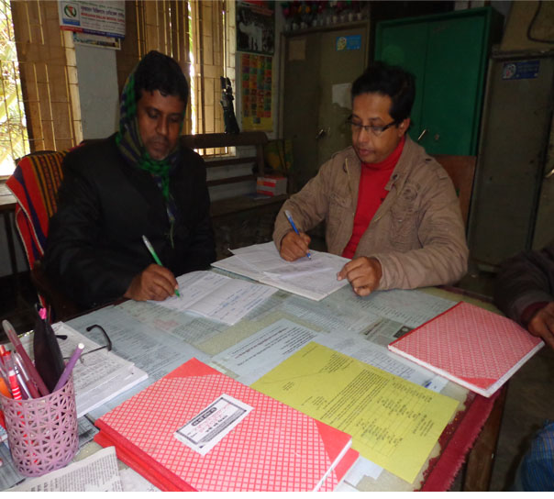
Upazila Managers, and Monitoring Officer of BDSC monitored the field regularly and talked with the student, teachers, SMC members regarding the programmatic issue. During monitoring, they checked the stock registrar, physically verified of the schools store, storage condition of the fortified biscuit, hygiene environment of the schools, cleanliness of students, condition of safe drinking water and condition of sanitary latrine. Project coordinator of BDSC also visited the field from time to time and gives inputs to the field staffs. Beside, Assistant Project Director of EU Assisted of School Feeding Programme has visited schools several times both the project areas (Dharampasha upazila in Sunamgonj district and Lakhai upazila in Hobigonj district.) and provided us some fruitful suggestions which helped the project implementation smoothly.

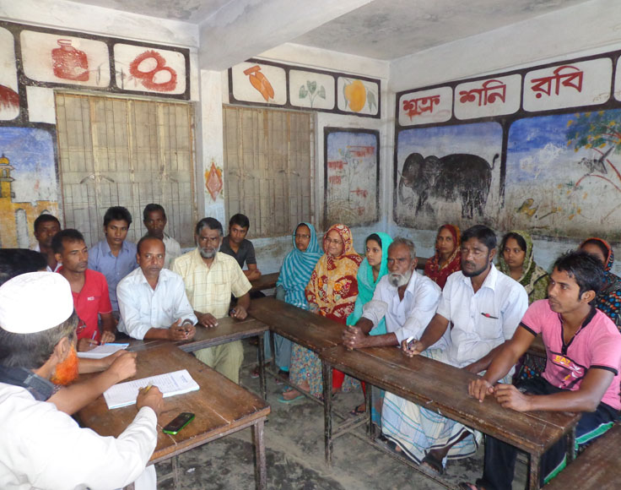
SMC Meeting: In presence of BDSC Staff, BDSC arranged SMC meetings at govt. primary school both the upazilas at Darampasha upazila in Sunamgonj district and Lakai upazila in Hobigonj district. Major agenda of those meetings were Monthly reporting, Biscuit distribution, Biscuit distribution follow up, report collection, biscuit transport, school registrar fortified biscuit distribution related, vegetable garden, kitchen garden and issue based discussion etc.
SMC Meeting at school level in Dharampasha
One of project achievement was that SMC chairperson/member build up a good relationship with school and community. For that project determined to arrange a quarterly SMC meeting in every school. We believed that SMC meeting was very effective for school feeding programme.
(b) Comparison of student’s different data between 2010 & 2015:
The initially project covered 25617 students and at the end of project this figure had been changed and enriched up to 30158 students. A total of 4145 students increased over the time.
The initial phase of the project following students got fortified biscuits in 2010 ;
Name of Upazila | Total Student)
Dharampasha | 13524
Lakhai | 12093
Grand Total | 25617

Since November 2015 number of students increased this elaborated herein under;
Name of Upazila | Total Students
Dharampasha | 16791
Lakhai | 13,367
Grand total | 30,158

05. Comments (Positive attitude) if any (may be visitor’s comments about your factory or NGO office)
During the project tenure a huge numbers of visitors from government counterparts, NGOs ,Civil Society members and local leaders paid visit to the program at different schools. According to our reports we found them very helpful and had given keen interest to continue the program at elsewhere in Bangladesh. It’s proved that after started the school feeding program a significant changes found in the primary schools. Remarkably reduced drop out and increased attendance rate in the primary schools.
Local officials like Upazila Nirbahi Officer (UNO) and others important persons visited program in different times. They gave their very good comments on the programme during addressing public meetings and other forums.
Biscuit factory was very cooperative and active in terms of continue and supply biscuits in time.
Even they showed their commitments forgetting their business opportunities. It was really laudable.
06. Conclusion
The overall objective of this project was to contribute to the achievement of MDG- 2 by improving the food security of the poor and ultra poor children of the targeted area, through distribution of fortified biscuits and accessing them to quality primary education. BDSC has completed all scheduled activities of the project. School feeding programme encouraged poor families to keep children in school as regular basis. The Government of Bangladesh was taken numerous measures to provide universal primary school education by 2015. The school feeding programme is one of the important measures, which the Government believes will enable it to achieve these commitments towards primary education. Government of Bangladesh , meanwhile , tried to reach some milestone achievement in primary education development and quality education issues. It will be expected in near future Bangladesh will touch the end line of the victory in terms of reaching agenda of quality education and reducing drop out from primary school.

